

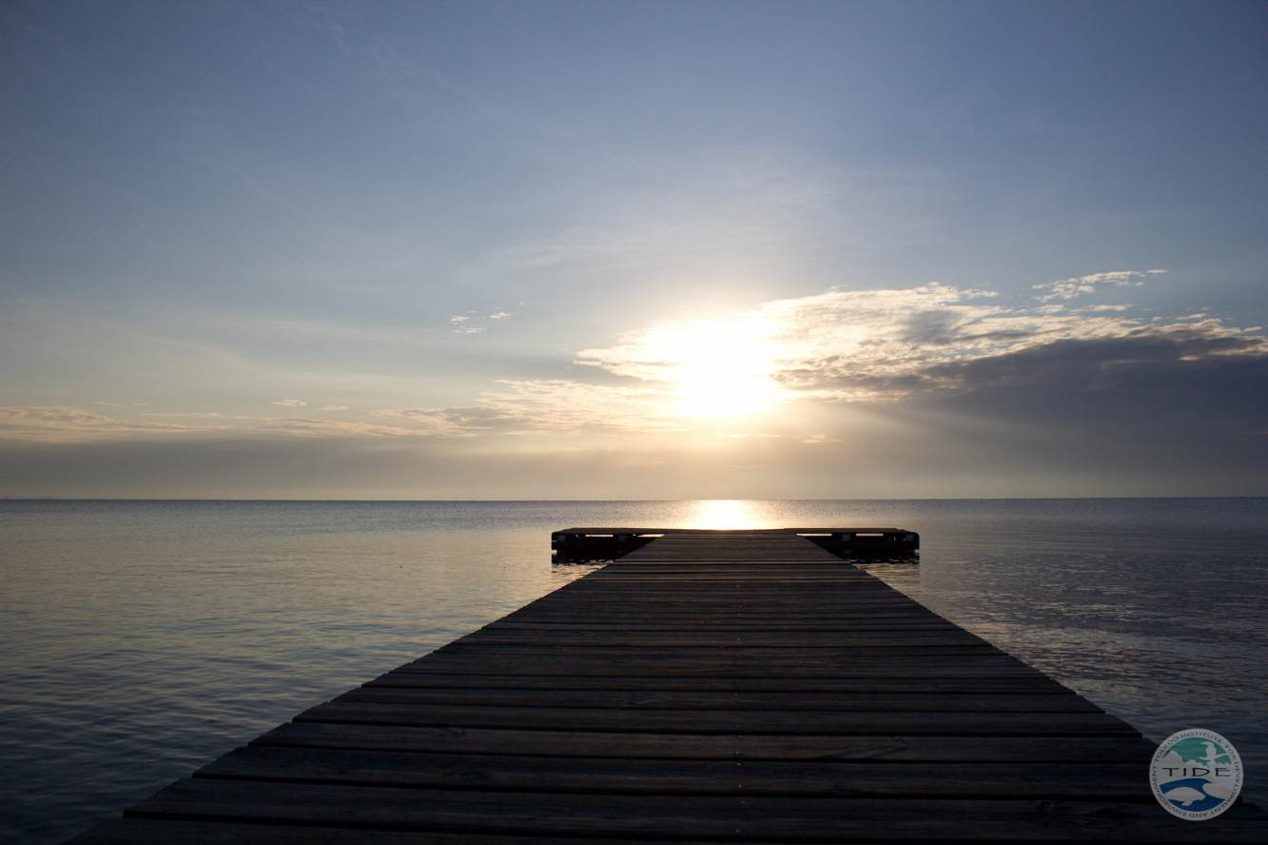

**Port Honduras Marine Reserve**

**Annual Report 2013**

**Seleem F. Chan**

**Marine Manager**

**Words from the manager**

It is with pride that I present to you the Port Honduras Marine Reserve (PHMR) annual report for 2013. This report summarizes the main activities that occurred throughout the year.

I am pleased to report the field staff conducted a total of 910 patrols. As a result of these patrols, 2 arrests were made and successfully prosecuted and the successful prosecution of two fishers that were charged from the previous year 2012. In addition, Nine (9) written warnings were issued to different fishers for the offense of conducting commercial fishing without a valid commercial fishing license. One (1) summons was issued to a fisher for conducting commercial fishing within a vessel not license to conduct commercial fishing; this case was lost in court due to insufficient evidence.

Patrols were conducted jointly with the Fisheries Department, Belize Defense Force, Immigration Department, Police Department, Tourism Police Department, the Belize Coast Guard, and personnel from other protected areas managed by TIDE. Efforts will be made to strengthen the relationships with these government agencies in 2014.

Once again, we would like to express our sincere gratitude to the Belize Fisheries Department, PHMR Advisory Committee, the Belize Coast Guard, Oak Foundation, Summit Foundation,

The National Oceanic and Atmospheric Administration (NOAA), Environmental Defense Fund, The Nature Conservancy, Sea Grass Net, New England Biolabs Foundation, MAR Fund, and COMPACT. Our work would not have been possible without the financial contribution and commitment from these partners throughout the year.

I would like to send a heartfelt thank you and special mention to buffer community members of Monkey River, Punta Negra, and Punta Gorda for their commitment and support. I would also like to thank the field and support staff at TIDE for their continued dedication throughout the year.

Sincerely,

Seleem Chan

Manager

Port Honduras Marine Reserve

**Table of contents**

1.0 Administrative 4

1.1 Staffing 4

1.2 Training 5

2.0 Background of PHMR 7

2.1 Introduction 7

2.2 Strategic Plan and Goals 8

3.0 PHMR Accomplishments 9

3.1 Patrols and Surveillance 9

3.2 Patrol Summary 2013 10

3.3 Infrastructure 12

3.3 Partners 12

4.0 Abalone Erosion 13

5.0 Community Education and Outreach 13

5.1 Managed Access in Belize 14

5.2 Managed Access License 14

5.3 PHMR Community M. A Committee 15

5.4 Daily Catch Logbook 15

5.5 M.A. Communication Plan 16

6.0 Visitors to PHMR 17

7.0 Users of the Reserve for 2013 21

8.0 TIDE Board of Directors 22

8.1 TIDE Staff 23

8.2 PHMR Advisory Committee 23

9.0 PHMR Donors 24

**1.0 ADMINISTRATIVE**

**1.1 STAFFING**

**PHMR Enforcement Staff (Table 1)**

|  |  |
| --- | --- |
| **Name** | **Position** |
| 1. Seleem Chan | manager |
| 1. Kenworth Martin | ranger |
| 1. Narciso Martinez | ranger |
| 1. Edwin Cabrera | ranger |
| 1. Aaron Garbutt | ranger |
| 1. Jimmy Boucher | ranger |
| 1. Henry Archer | ranger |

**Head Ranger Position**

In the year 2013, the head ranger position became vacant after Mr. Kenworth Martin was demoted from his position on November 14. Mr. Martin was demoted as a result of him neglecting his responsibilities and was unable to work as a team with his fellow rangers.

Within the year 2014, the head ranger position will be advertised in an effort to re-hire a well-trained person.

**PHMR Research Team (Table 2)**

|  |  |
| --- | --- |
| 1. James Foley | Science Director |
| 1. Tanya Barona | Biologist |

The science team for PHMR also received changes in staff for 2013. On September 13, 2013, Ms. Gail Mac Nab resigned from her post of Research Assistant and Mr. Marlon Williams also resigned from his post as Biologist.

Ms. Tanya Barona was hired as the new Biologist and is presently on a three months probationary period. In the year 2014 a decision will be made if Ms. Barona will be hired on a permanent basis, this will be based on her evaluation of completing her probationary period.

**Community Researchers and Volunteers (Table 3)**

|  |
| --- |
| 1. Jenivieve Ramirez |
| 1. Victor Willams |
| 1. Dario Williams |
| 1. William Caal |
| 1. Gean Castellanos |
| 1. Fernando Rabatu |
| 1. Allana Barillas |
| 1. Arielle Coleman |

**1.2 TRAINING**

Developing new skills and increasing your capacity in your particular position at TIDE is an annual activity. Staff members are given the opportunity to participate in trainings on an annual basis. Table 4 below shows the trainings accomplished for 2013. Also Table 5 expresses the training needs for 2014.

(Table 4)

|  |  |  |
| --- | --- | --- |
| **Area of Training** | **Area of Training** | **List of Participants** |
| **Enforcement** | 1. Training entitled: Communications/Marine Enforcement Strategy of the Belize Fisheries Department | **Mr. Kenworth Martin and Edwin Cabrera** |
| **Capacity Building** **workshops/Trainings** | 1. Training course on Conservation Financing 2. Training course on Effective Management by Mr. Alfredo Cruz 3. Training course on Effective Management 4. Training on Levels B & C of the Spanish Language at the Spanish Christian Academy 5. Training on PADI Rescue Diver 6. Training on PADI Open Water Diver 7. Training on SMART Enforcement Database 8. Training on basic GIS 9. Training in Public Relations | **Mr. Edwin Cabrera**  **Mr. Seleem Chan**  **Mr. Kenworth Martin**  **Mr. Seleem Chan**  **Mr. Seleem Chan & Mr. Marlon Williams**  **Mr. Kenworth Martin & Mr. Edwin Cabrera**  **Entire Staff**  **Entire staff**  **Entire staff** |

**(Table 5)**

|  |  |
| --- | --- |
| RANGERS | Engine and boat maintenance (annually) |
| Boat handling training (Port Authority Basic Training) |
| Enforcement training (annually) |
| Weapons handling |
| Report writing |
|  | PADI Rescue Diver/Dive Master Training |
| **MANAGER** | Proposal writing skills |
|  | **Communication Skills** |
|  | **Report Writing** |
|  | Additional Management Courses |

**2.0 Background of Port Honduras Marine Reserve (PHMR)**

**2.1 Introduction**

Declared by the Government of Belize in January 2000, the PHMR is being actively co-managed by TIDE and the Fisheries Department. PHMR covers approximately 160 square miles and is an integral part of the Maya Mountain Marine Corridor (MMMC) in southern Belize. The reserve is located just off the coast of Punta Gorda and extends to just north of Monkey River Village. PHMR comprises of all the coastal wetlands, sea, seabed, and national lands within the area known as the Port Honduras, with general boundaries being the Rio Grande in the south, Monkey River in the north, the snake cayes in the east and the coastal wetlands in the west. The reserve is rich in biodiversity, containing approximately 138 small mangrove cayes, which provide essential habitat and nursery for juvenile aquatic species. Other critical habitats include sea grass beds, hard bottom communities, and soft bottom communities. A large portion of the reserve is covered by sea grass, which also provides essential habitat and food for juvenile fish species, sea turtles, salt water crocodiles, and manatees. Also within the reserve you find fringing reefs and several coral patches and coral heads, which provide a habitat for vertebrates and invertebrates.

There are two villages located in the reserve, Monkey River Village and Punta Negra Village. The residents of each village are mostly commercial fishers, tour guides, or fly-fishing guides who depend on the reserve for their livelihood.

**Map of Port Honduras Marine Reserve (Map 1)**

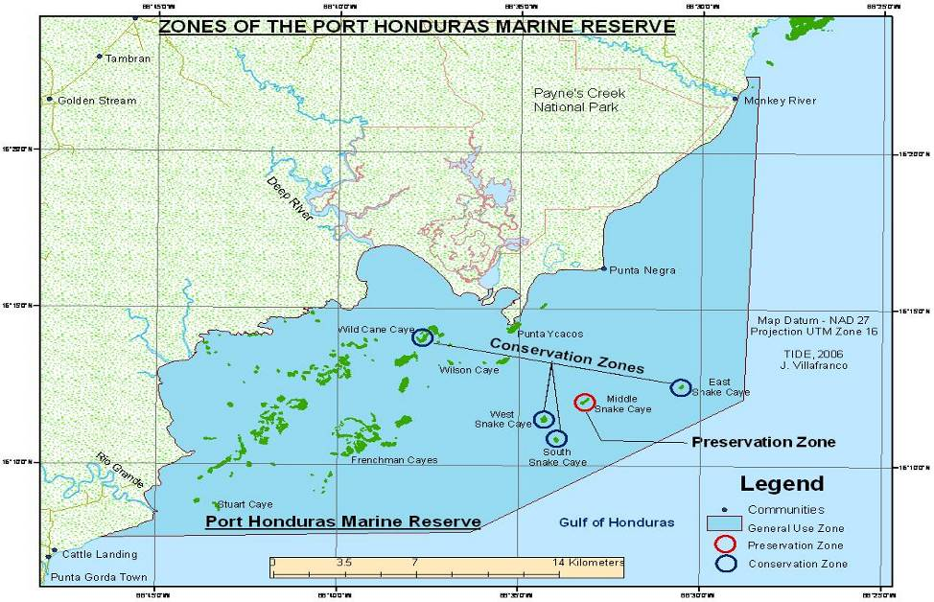

**2.2 Reserve’s Strategic Plan and Goals**

The PHMR management strategy is based on five major goals:

1. To protect the physical and biological resources of Port Honduras
2. To provide education and research
3. To preserve the value of the area for fisheries and other important genetic resources
4. To develop recreational and tourism services that will enhance the economic and social benefits of the area without causing environmental damage
5. To strive for sustainable financing

**Zoning Plan and Regulations**

For the purpose of the regulation and control of the Reserve, five zones were established:

1. **General Use Zone** (95% of the Reserve)

To provide opportunities for established uses and activities (e.g. fishing for conch, lobster, and finfish) under a stringent monitoring scheme

2. **Conservation Zone**

To provide an area free from commercial fishing to prevent overexploitation of fishery stock, provide an undisturbed area for recruitment of species, and enhance the value of the area for recreational and tourism activities

3. **Preservation Zone**

To provide areas within the marine reserve that are preserved in an entirely natural state and to protect areas of particularly fragile habitat or with threatened or rare species

4. **Special Management Area**

Area reserved for special projects

**3.0** **PHMR Accomplishments 2013**

**3.1Patrols and Surveillance**

A total of 910 patrols were conducted for 2013. The targeted number of patrols for 2013 was 900, we are pleased to express we have met our target. As a result of these patrols 16 gillnets were confiscated within the boundaries of the reserve. Two (2) local fishers from Moho River area, Toledo District was summons to court and successfully prosecuted for use of three gillnets within the boundaries of the reserve and two (2) local fishers from Punta Negra that were summoned to court for conducting fishing without a Managed Access License and the other for conducting commercial fishing without a Commercial fishing license and a Managed Access License were successfully prosecuted for the charge of conducting fishing without a Special License (Managed Access license). Both fishers were charged a total of $1000 Belize currency within three months, in default three months imprisonment. The charge of conducting commercial fishing was dismissed due to lack of evidence.

Nine (9) written warnings were issued to different fishers for the offense of conducting commercial fishing without a valid commercial fishing license. A decision was made by the officers on patrol not to carry out arrests because this occurred within the month of January 2013. One (1) summons was issued to a Mr. Carlos Bardalez for conducting commercial fishing within a vessel not license to conduct commercial fishing; this case was lost in court due to insufficient evidence.

Table 6 summarizes the number of patrols done for 2013 and also includes the number of night, day and joint patrols, number of patrols conducted outside of the boundaries of the reserve as well as warnings for first offence and number of gill nets confiscated.

Figure 1 provides an 11 year trend showing number of patrols conducted, gillnets confiscated and number of arrests made. A brief analysis of the data shows a decrease in the number of patrols conducted as the years progress. From the patrols conducted, this resulted in 16 gill nets confiscated within the reserve and two (2) Fisher folk being arrested/summoned to court.

**3.2 (TABLE 6: Patrol summary for 2013)**

|  |  |  |  |  |  |  |  |  |
| --- | --- | --- | --- | --- | --- | --- | --- | --- |
| **Month** | **Day Patrols within the reserve** | **Night Patrols within the reserve** | **Joint Patrols**  **(figure already included)** | **Day patrols Outside reserve boundary** | **Night patrols outside reserve boundary** | **Arrests/**  **summons** | **Sub Totals** | **Comments** |
| Jan | 42 | 16 | - | - | - | - | 58 | 9 warning letters issued for fishing without a valid fishers license |
| Feb | 48 | 17 | 1 | 8 | - | - | 73 |  |
| Mar | 50 | 10 | - | 5 | - | - | 65 |  |
| Apr | 55 | 6 | 1 | 10 | - | - | 71 |  |
| May | 59 | 15 | - | 8 | - | - | 82 | 2 gillnets confiscated in the area of Monkey River |
| Jun | 54 | 19 | - | 10 | - | - | 83 | 1 gillnet confiscated in the area of Monkey River |
| Jul | 43 | 13 | - | 6 | - | 1 | 62 | 1 summons issued |
| Aug | 39 | 19 | - | 1 | 1 | - | 60 |  |
| Sept | 60 | 27 | - | 4 | - | 2 | 91 | 2 fishers successfully prosecuted for illegal setting of gill nets |
| Oct | 51 | 24 | 3 | 2 | - | - | 77 |  |
| Nov | 57 | 21 | 2 | 8 | - |  | 86 |  |
| Dec | 80 | 13 | - | 9 | - | - | 102 |  |
| **Totals** | **638** | **200** |  | **71** | **1** |  | **910** |  |

**Enforcement trend in PHMR**

**Figure 1**

**3.3 Infrastructure**

On January 3 – 5 2013, a team from Eco Friendly Solutions was transported out to Abalone Caye to install a new compost toilet within the ranger station. The previous system was not working properly, so it was replaced with a new bio-digester and a settling tank for the gray water. The gray water is then leaked out into a leach field on the island.

Also, within the month of June 2013, a butane refrigerator was purchased with funding under the KFW project. As a result of this TIDE no longer has to be purchasing ice on a weekly basis for the rangers.

Other infrastructural accomplishments are the reroofing of the ranger station, signed contract with Christopher Nesbitt to reinstall a new solar system, and purchasing of a new dinning/conference table for Abalone Caye Ranger Station.

**3.4 Partnerships**

The PHMR staff continues to work with local and partner organizations, these partners include Southern Environmental Association, the Fisheries Department, the Police Department, the Belize Defense Force, the Belize Coast Guard, and the University of Belize.

**4.0 Erosion of Abalone Caye**

**Figure 2**

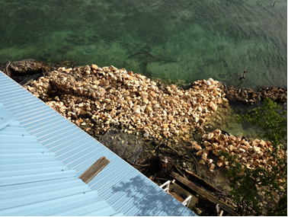In an effort to continue to the work started in 2011, additional gabion baskets and rocks have been purchased and transported to Abalone Caye. Major work has been done concentrating on the eastern side of the island, shown here in the picture provided.

With funding through our KFW project two teams were hired to transport rocks out to the island. Rangers on duty assisted by constructing gabion baskets which will be placed in strategic locations and filled with rocks, this activity will be continued into the year 2014. This labor intensive activity is back breaking work but is being accomplished. One ranger who has vested a lot of time and his attention into this project is Mr. Narciso Martinez. He has assisted tremendously.

**5.0 Community Education and Outreach**

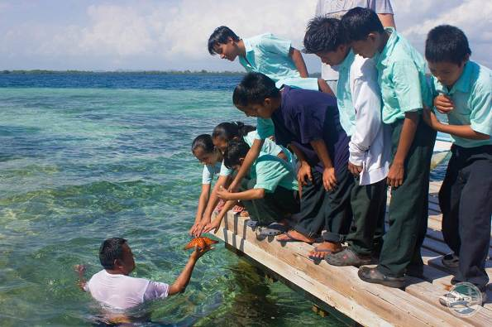As a part of implantation of our KFW German funding project, a number of field trips were made into the three protected areas managed by us at TIDE. Each trip took a total of twenty two (22) primary school children along with their teachers to learn first-hand about the linkages between the terrestrial environment and the marine. Children from schools within rural Toledo got the chance to see marine creatures like a sea star for the first time. The importance of protecting both terrestrial and marine ecosystems was stressed throughout the adventure. The main highlight of the trip was when the children got the opportunity to swim at West Snake Caye.

A Catering and Food Handling Training was also accomplished by TIDE with the assistance of Ms. Olive Woodye. The participants were the wives of Managed Access Fishers of PHMR or a Managed Access licensee themselves. Ms. Woodye trained a group of seven women from Punta Gorda in the culinary arts. Plans are to provide

***5.1 Managed Access in PHMR***

**Overview**

Managed access refers to a license system that grants access to fishing in the general use zones of marine reserves. Managed access license system was implemented in 2011 as part of a two year Transition Period for fishermen and managers to adjust to the Managed Access system. Almost a hundred consultations with fishers on Managed Access have occurred at Port Honduras Marine Reserve’s (PHMR) buffering communities since 2009. At the implementation of this program, the Port Honduras Marine Reserve Community Managed Access Committee was formed to evaluate applications for managed access licenses for fishers of PHMR and make recommendations to the Fisheries Department. The PHMR Community Managed Access Committee members consist of representatives from Monkey River, Punta Negra, and Punta Gorda communities, the Fisheries Department, Rio Grande Fishermen Cooperative and the Toledo Tour Guide Association.

Fishers who have obtained a Managed Access license are expected to comply with Fisheries Regulations and conditions of the license such as submission of catch data on a regular basis. Managed access uses a fishers’ right-based approach to create incentives for fishers to become better stewards of their environment and marine resources.

**5.2 Managed Access License**

As of December 9, 2013 a total of 103 fishers have been recommended by the PHMR Community Managed Access Committee and a pre-approved list has been submitted to the Fisheries Administrator. A total of 30 fishers have not been recommended for managed access license since they did not fulfill the license criteria (8 fishers from Monkey River, 20 from Punta Gorda and 2 fishers from Punta Negra).

Fishers will be able to make payments for renewal of general fisher folk license and managed access at the Punta Gorda Treasury- Sub office. As of December 16, 2013, a total of 10 Managed Access fishers have paid the renewal fee through the Treasury Sub-office for their 2014 Managed Access License. TIDE Managed Access Officer is contacting fishers to encourage them to renew their managed access license. Fishers were urged to provide all necessary documentation to the clerk at the Fisheries Department office in Punta Gorda where the payment form will be filled out so as to facilitate payment at the Treasury Sub-office. Required documents include two forms of identification, a utility bill, receipts of sale of marine product and a photocopy of current general fisher folk and managed access licenses.

**5.3 PHMR Community Managed Access Committee**

A total of 4 meetings were held by the PHMR Managed Access Committee for the year 2013, all meeting were to vet new managed access applications and to discuss issues raised from Managed Access in PHMR in 2013.

**5.4 Daily Catch Log Book**

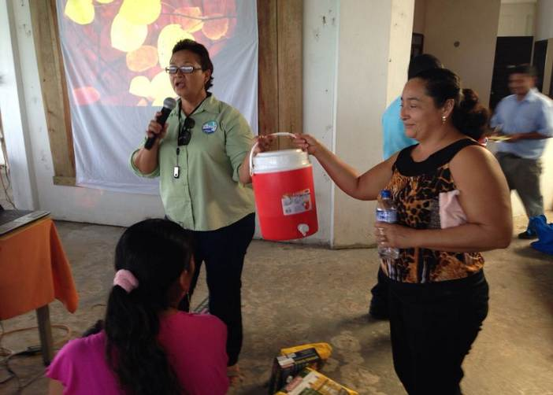As the year progressed and with constant one-on-one sessions with fishers and PHMR Managed Access Coordinator and TIDE Managed Access Officer, fishers’ data recording and submission have increased dramatically. However, it has been noted that some fishers are still not accurately filling out data log sheets. For example, fishers are missing the date or not placing the exact date of fishing trip and various common names used for fish species. It has been challenging for fishers to submit data on a daily basis due to time, distance of fishing areas to Abalone Ranger Station and Fisheries- Punta Gorda. Thus, fishers have been able to submit data on a weekly basis or every two weeks. However, there are fishers who are submitting log sheets after a month. Most fishers know that data must be submitted and recognize the importance of data especially in renewal of licenses.

Incentives were given to some managed access fishers for the quality and amount of data sheet that was submitted.

Of one hundred and twenty six (126) Managed Access fishers in 2013, ten (10) fishers had great data submission (30 data sheets and over), thirty four (34) fishers in compliance (7 to 30 data sheets), forty seven (47) fishers with few data submission (6 and under) and (thirty four) 34 fishers with no data submission.

Table below shows the top ten (10) Managed Access fishers who submitted (thirty) 30 data sheets and over for 2013. All ten Managed Access fishers were awarded with incentives at the Managed Access Forum on November 28,2013.

|  |  |  |  |
| --- | --- | --- | --- |
| Jorge Ramirez | Yes | 95 | 40 |
| Anna Ramirez | Yes | 56 | 15 |
| Rodan Luis Cabrera | Yes | 47 | 26 |
| Oljer Leonel Delcid | Yes | 46 | 30 |
| Omar Westby | Yes | 46 | 20 |
| Reynaldo Arnaldo Ramirez | Yes | 45 | 12 |
| Carlos Herman Ramirez | Yes | 44 | 21 |
| Juanita J. S. Ramirez | Yes | 41 | 10 |
| Joel Edrick Casimiro | Yes | 33 | 24 |
| Ernest Harrison Logan | Yes | 32 | 5 |

**5.5 Managed Access Communication Plan**

**Outreach for Managed Access**

Senior Community Stewards Program

As part of a COMPACT project currently implemented by TIDE, the Senior Community Stewards program has been continued. Currently there are 7 senior community stewards who have been trained in the Managed Access program, importance of daily catch log data, and how to properly fill daily catch log books. These stewards have been reaching out to Managed Access fishers so as to do sessions on how to properly fill daily catch log books and on Managed Access. Thus so far, the 4 stewards have been able to reach out to a total of 65 fishers. Each fisher has received a fish ID card so as to properly document and improve the quality of data submitted by each fisher. The fish ID cards will improve data collected since it will standardize the manner in which fish species are recorded. TIDE Managed Access Officer assisted some of the stewards in visits to the Managed Access fishers to communicate with them and get their feedbacks on filling out their catch logs.

**6.0 Visitors to PHMR**

Americans continue to be our most frequent guests within Port Honduras Marine Reserve with a total of 463 guests which is an increase by 43 guests as compared to 2011 figures. A total of 290 Belizeans signed the logbook at Abalone; this also shows an increase of 75 Belizeans. A brief analysis of the data shows an increase in the number of both Belizean and American visitors comparing 2010 and 2011 data. This is shown in Figure 3.

Table 6 below provides you with visitation data depicting the number of visitors per month and country of origin for 2012.

Figure 4 depicts PHMR’s visitation trends from 2003 to 2012. The highest visitation numbers were observed in the year 2006 with a total of 1035 visitors.

There are visitors that venture direct to West Snake Caye, an island within the Conservation Zone and do not visit the ranger station so a record of their visit is not recorded in the log book. To address this concern, a second method of collecting visitor’s data was implemented. This is shown in Figure 5.

**TABLE 6: Visitation to PHMR for Jan-Dec 2013 by Country (Data from the Logbook at Abalone Ranger Station)**

|  |  |  |  |  |  |  |  |  |  |  |  |  |  |
| --- | --- | --- | --- | --- | --- | --- | --- | --- | --- | --- | --- | --- | --- |
| **Country** | **Jan** | **Feb** | **Mar** | **Apr** | **May** | **Jun** | **Jul** | **Aug** | **Sept** | **Oct** | **Nov** | **Dec** | **Totals by Country** |
| USA | 135 | 74 | 92 | 23 | 69 | 35 | 59 | 13 | 2 | 16 | 15 | 5 | 538 |
| Belize | 3 | 3 | 32 | 5 | 17 | 28 | 94 | 50 | 4 | - | 39 | 41 | 316 |
| Sweden | 4 | - | 30 | - | - | - | - | - | - | - | - | - | 34 |
| Europe | 18 | - | - | - | - | - | - | - | - | - | - | - | 18 |
| Canada | 8 | 2 | 8 | 25 | 10 | 3 | 1 | - | - | 3 | 2 |  | 62 |
| Japan | 1 | - | - | - | - | - | - | - | - | - | - | - | 1 |
| France | 2 | - | - | - | - | - | - | 3 | - | - | - | - | 5 |
| Guatemala | 2 | - | - | - | 1 | - | - | - | - | - | 1 | - | 4 |
| Alaska | 2 | - | - | - | - | - | - | - | - | - | - | - | 2 |
| United Kingdom | 2 | - | 1 | - | 2 | 4 | - | 4 | - | 1 | 2 | 1 | 17 |
| Mexico | - | 1 | - | - | - | - | 1 | - | - | - | - | - | 2 |
| German | - | 2 | 2 | - | - | - | - | - | - | - | - | 1 | 5 |
| Australia | - | - | 2 | - | - | - | - | - | - | - | - | 1 | 3 |
| Ireland | - | - | 4 | - | - | - | - | - | - | - | - | - | 4 |
| Italy |  | - | - | 4 | - | - | - | - | - | - | - | - | 4 |
| El Salvador | - | - | - | - | 1 | - | 1 | - | - | - | - | - | 2 |
| Honduras | - | - | - | - | - | - | - | 7 | - | - | - | - | 7 |
| Other | 44 | 85 | - | - | 1 | 2 | 1 | - | 2 | 1 | - | - | 136 |
|  | 221 | 167 | 173 | 57 | 99 | 72 | 157 | 77 | 8 | 21 | 59 | 49 | **1,160** |

**Figure 3: Visitation data by country for 2010, 2011, 2012 and 2013(Note: data collected is only from guests that sign into the logbook at Abalone Caye Ranger Station)**

**Figure 4: Visitation Trends for PHMR since 2003 - 2013**

**Figure 5: Visitation Data collected within PHMR**

* 1. **(Table: 7) Users of the Reserve and vessel names for 2013**

|  |  |
| --- | --- |
| **Fisherfolk** | **Boat Name** |
| 1. Marcial Mes | Lynn |
| 1. Carl Gonzalez | Carlita |
| 1. Martin Reyes | Charity |
| 1. Eloy Cuevas | Trouble |
| 1. Nery Coleman | Yomira |
| 1. Winsley Garbutt | Dania |
| 1. Alvaro Romero | Bruno |
| 1. Alfredo Canelo | Puma |
| 1. Esquivel Ramirez | Ever |
| 1. Leslie Williams | Silence |
| 1. Darwin Garbutt | Delanie |
| 1. Lionel Delcid | Gilda |
| 1. Cristian Trapp | Marie Julie |
| 1. Felix Gutierrez | Janett |
| 1. George Ramirez | Viviana |
| 1. Darwin Garbutt | Delanie |
| 1. Martin Reyes | Charity |
| 1. George Garbutt | Mystic |
| 1. Jose Ariola | Andrea |
| 1. Ray Arzu | Sheridan |
| 1. Rafael Ramirez | Anna |
| 1. Beham Parham | Mariela |
| 1. Leonardo Garcia | Evelyn |
| 1. Ezequiel Ramriez | Mariela |
| 1. Walton Parham | Maria Juli |
| 1. Kent Audinett | Admiral |
| 1. Jason Martinez | Big Game |
| 1. Roy Ramirez | Tesha |
| 1. Geovanni Ramirez | Eagle |
| 1. Conrado Perez | Mirrza |
| 1. Freddy Perez | Paola |
| 1. Roberto Echavarria | Wild Thing |
| 1. Valerio Perez | Delfin |
| 1. Wilder Parham | Alejandra |
| 1. Daniel Tillett | Tunvo |
| 1. Marcos Barrientos | Paloma |
| 1. Abraham Perdomo | Lewis |

***(This list is just a representation of the fishers using PHMR)***

#### *(Table: 8) Sport Fishing/tour guides and their vessel names 2013*

|  |  |
| --- | --- |
| 1. Mikhail Martin | Brown Sugar |
| 1. Eworth Garbutt | Destiny |
| 1. Lionel Martin | Tight line |
| 1. Daniel Castellanos Jr. | Xavi |
| 1. Ian Cuevas | Opportunity |
| 1. George Garbutt | Mystic |
| 1. Eloy Cuevas Sr. | Fugitive |
| 1. Oliver Garbutt | Sea Life |
| 1. Thomas Garbutt | Unity |
| 11. Wilfred Mutrie | - |

**8.0 TIDE Board of Directors**

|  |  |
| --- | --- |
| 1. Gabriel Roches (Chair) | Public Officer (Public Health) |
| 1. Alistair King (Vice) | *Local Businessman (Texaco & Fabrigas)* |
| 1. Alexander Garbutt Sr. | *Local Fisherman and Tour Guide in Monkey River* |
| 1. Eric Moore – Treasurer - | *Ministry of Works, Toledo* |
| 1. Marie Aleman – *Retired* |  |
| 1. Dale Gomez – | PCNP Advisory Council representative |
| 1. Dr. Phillip Morgan | PHMR Advisory Council representative |
| 1. Celia Mahung | Executive Director (Ex-Officio) |

**8.1 TIDE Staff**

**Management Staff**

|  |  |
| --- | --- |
| 1. Celia Mahung | Executive Director |
| 2. Stephene Supaul | Operations Director |
| 3. Joseph Villafranco | Program Manager |
| 4. James Lord | Development Director |
| 5. Norman Budna | Education and Outreach Coordinator |

**Administrative staff**

|  |  |
| --- | --- |
| 1. Danny Hun | Financial Administrative |
| 2. Kimberly Coleman | Accounts Clerk |
| 3. Paul Etienne | IT Officer |
| 4. Claudette Borland | Office maintenance |

**8.2 PHMR Advisory Committee**

|  |  |
| --- | --- |
| Mr. Alex Leonardo/Mr. Dennis Garbutt | BTIA-PG |
| Mrs. Celia Mahung/Mr. Seleem Chan | TIDE Executive Director |
| Hon. Micheal Espat | Toledo East Representative |
| Mr. Eloy Cuevas Jr. | Monkey River Village |
| Mr. Anthony Fuentes | Mayor, PG Town Council |
| Mr. Armando Ramirez | Rio Grande Fisherman Cooperative - PG |
| Mr. Lyndon Rodney/Mr. Victor Vasques | Fisheries Department - PG |
| Mr. Philip Morgan | University of Belize – Toledo Campus |
| Ms. Paula Williams/Ms. Suzette Jacobs | Punta Negra Village (Chairlady) |

**9. 0 PHMR Donors**

1. The OAK Foundation
2. National Oceanic and Atmospheric Administration (NOAA)
3. The Nature Conservancy
4. The Summit Foundation
5. COMPACT
6. Sea Grass Net
7. Environmental Defense Fund
8. Belize Fisheries Department
9. KFW-German Bank
10. Marfund
11. New England Bio-labs Foundation