TOLEDO INSTITUTE FOR DEVELOPMENT AND ENVIRONEMNT

(TIDE)

CONGRESSIONAL REPORT
TROPICAL FOREST AND CONSERVATION ACT (TFCA) FUNDS

JANUARY – DECEMBER - 2019
Submitted to the United States Congress

December 2019

Background
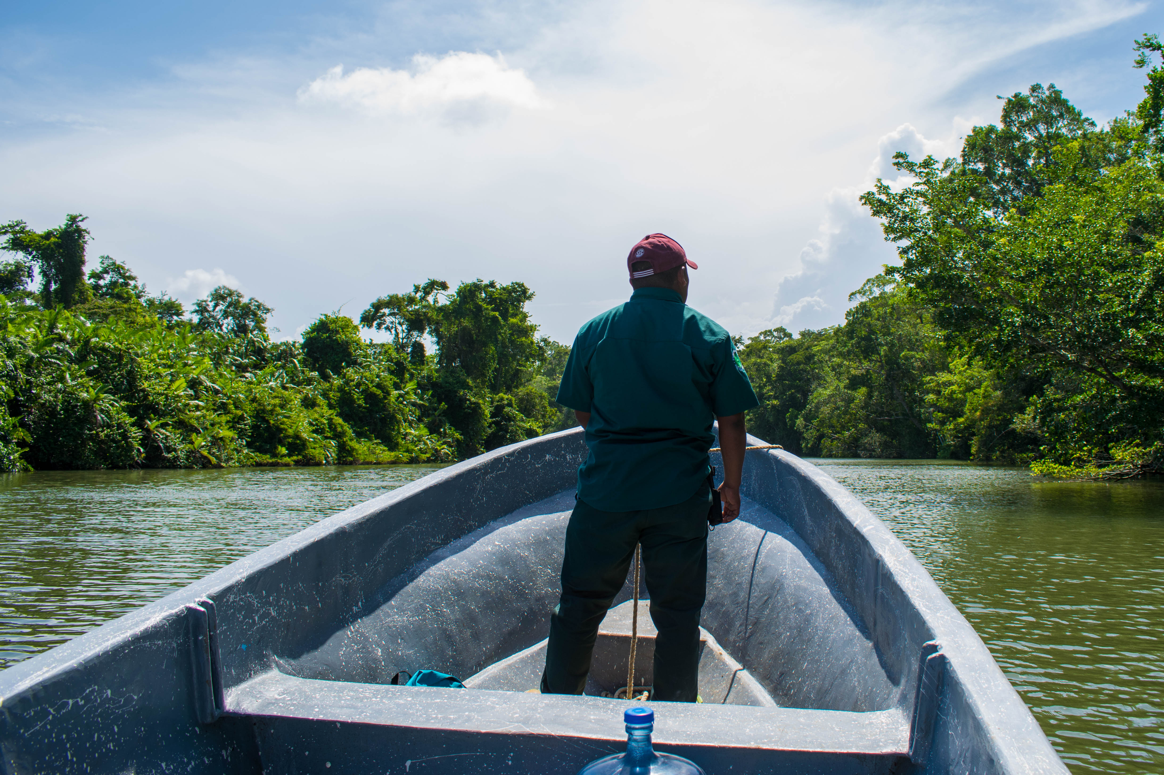
The Toledo Institute for Development and Environment (TIDE), a non-governmental organization, was founded in 1997 to meet the growing environmental and development needs of Toledo District, the southernmost district of Belize. TIDE was conceived as a grassroots initiative in response to the negative environmental effects from activities such as manatee poaching, illegal fishing, illegal logging, destructive farming methods, and unsustainable development. Initially started by volunteers, TIDE has now grown to include over 30 full time staff members.
In accordance with the overall goal of maintaining connectivity between the protected areas and minimizing the negative and harmful impacts on protected areas, TIDE acquired lands through the Tropical Forest Conservation Act, particularly in the Maya Mountain Marine Corridor (MMMC) which is a high priority conservation area, extending from the crest of the Maya Mountains in southwestern Belize to the southern end of the Belize Barrier Reef System. Today, TIDE manages over 20,000 acres of private protected lands under the Forest Conservation Act.
Activities conducted during the year 2019 concentrated around five major areas
- the establishment, protection, and maintenance of parks, protected areas, and reserves and
- (ii) the development and implementation of scientifically sound systems of natural resources management, including land ecosystems management practices;
- (iii) training programs to increase the scientific, technical and managerial capacities of individuals and organizations involved in conservation efforts and
- (iv) the restoration, protection, or sustainable use of diverse animal and plant species.

Major Achievements in 2019
Sharing information with stakeholders buffering TPPL
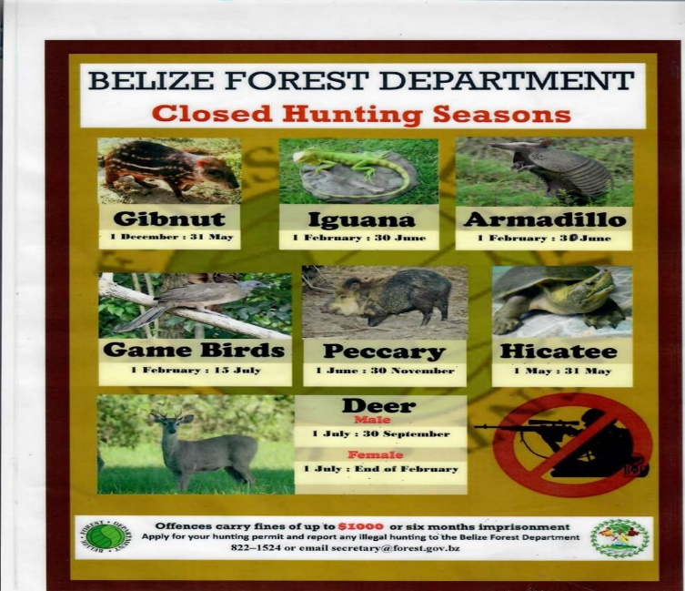
Keeping stakeholder informed of TIDE work is crucial to effective management of natural resource within the MMMC. TIDE Ranger staff continued sharing information with land owners and farmers about the importance of retaining 66 feet buffer zone on the river banks particularly in the areas along San Marcos to Jacinto Creek where there are signs of de-forestation.
Flyers with information about Hicatee were distributed during house to house visits in Cuxlin Ha. Information on closed and opened seasons for hunting different game species in accordance with the laws were also shared in various buffering communities. We have discovered that since there are new residents in these communities on an annual basis, there is need for ongoing education and outreach. Though we know from reports made about illegal hunting that some community members are interested in abiding by laws and regulations, there is always need for ongoing outreach and surveillance to protect biodiversity.
Surveillance and Patrols
TIDE ranger continued both land and water-base patrols during this reporting period. Patrols included monitoring of existing fishing and hunting camps along river banks and coastal areas. These sites were recorded as either active or inactive with the usage of the SMART technology, when it was operational. During this reporting period, rangers had difficulty with Garmin Monterra that is used for data collection so maps do not capture all observations during patrols.
SMART Technology gathers information on patrols routes, human encounters, human activities, recreational activities and wildlife sightings. Some of the wildlife sightings include: Tapir, Jaguar, Howler Monkeys and crocodiles.

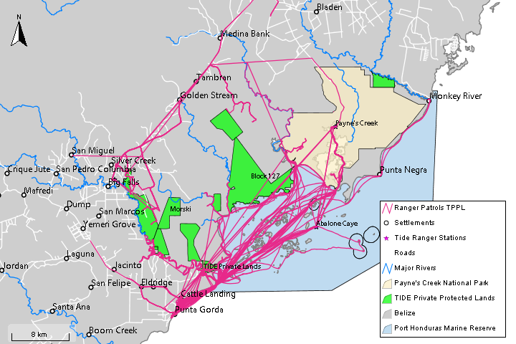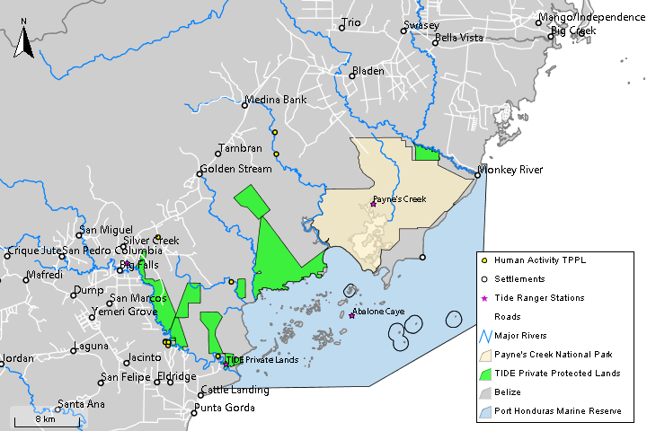
Patrol Routes Human Activity
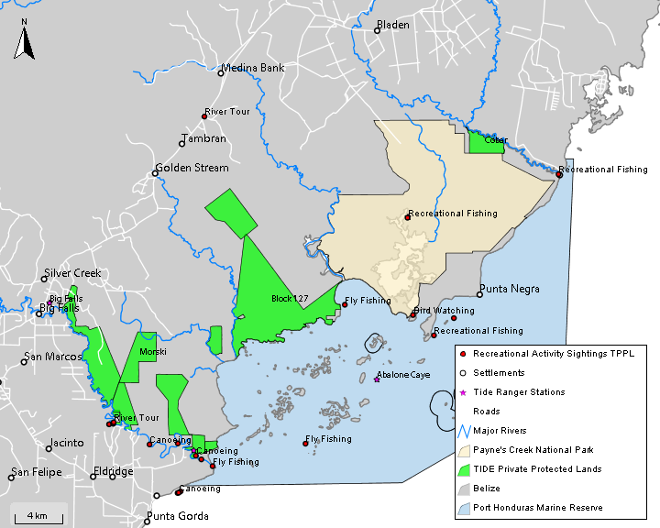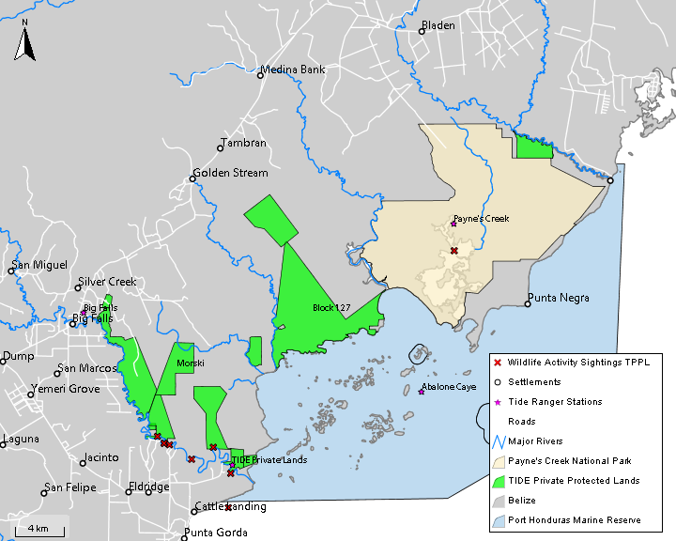
Recreational Activity Wildlife Sighting
During a night water-based patrol, rangers came across a gillnet measuring 147 feet. The net did not have a tag and apparently was illegally set across the river shortly after rangers found it. The gillnet was confiscated and handed over to the Belize Fisheries Department; however, personnel from the department informed head ranger that case file was not strong enough to take the matter to court. The net was returned to owner. This scenario made us aware that rangers needed further training in case file preparation.
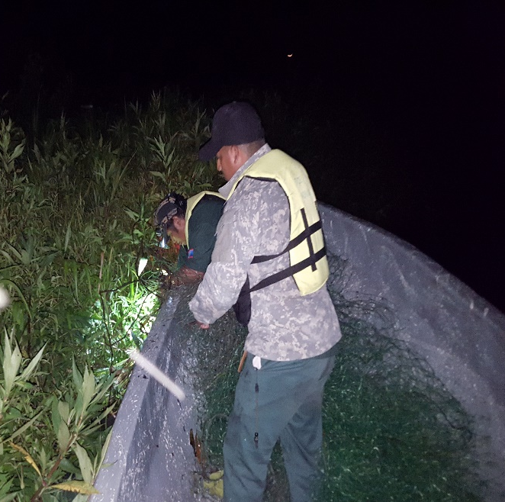
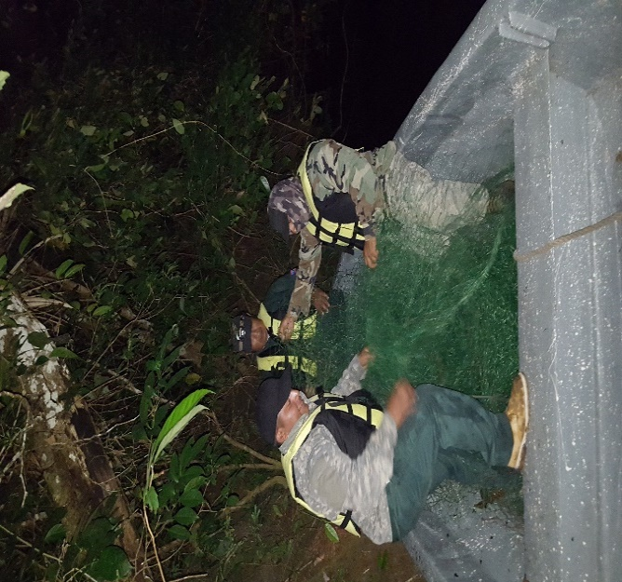

Work with Ridge to Reef Expedition and volunteers.
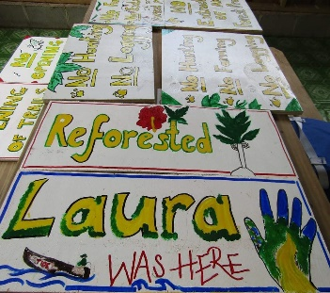
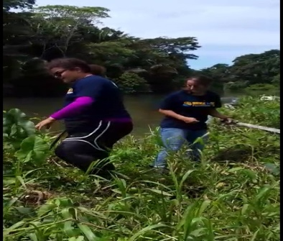
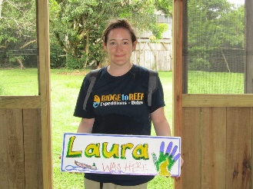
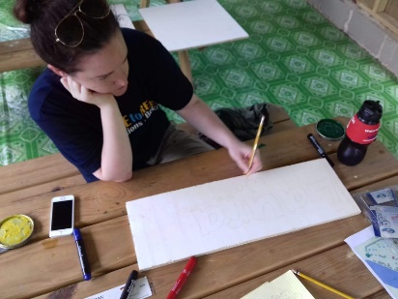
Park rangers continue to host Ridge to Reef volunteers at TPPL who not only assist with numerous activities, but compensate TIDE for offering a conservation experience. They help with signage on trails and along the riparian zones, birding, trail and compound maintenance and reforestation activities. Volunteers are a huge help to rangers on the TPPL.

Infrastructure to Host research students
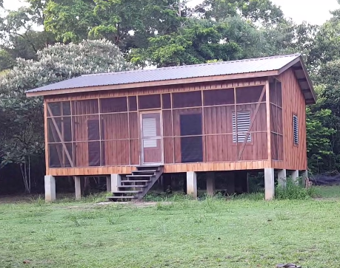
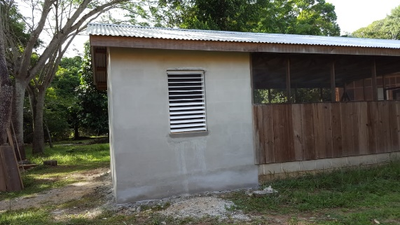
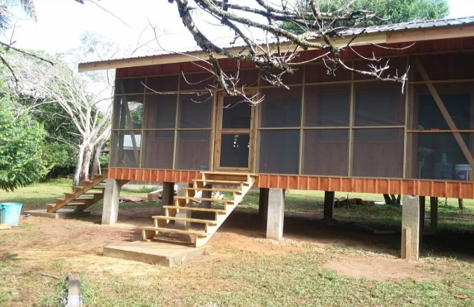
Two cabins were built on the TPPL (Starcher Property) to accommodate university groups and families interested in participating in conservation related activities. A kitchen has been added to the dining area kitchen utensils, equipment and furniture will also be procured. We hope to fully equip buildings by mid-2020.
There was also a huge investment in equipping the Big Falls property, now the Big Falls Retreat, registered with the Belize Hotel Association. The Big Falls Retreat and educational facility was fully furniture to host university groups and is expected to help generate some funding for management of the TPPL.
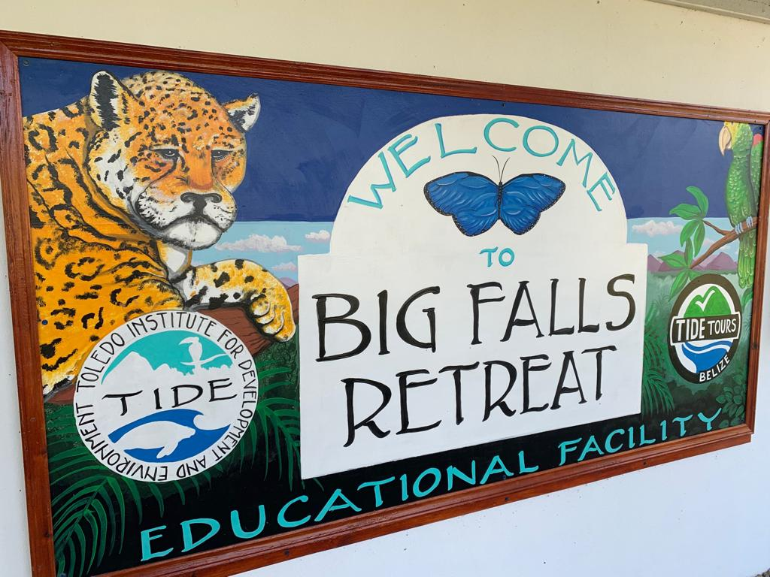
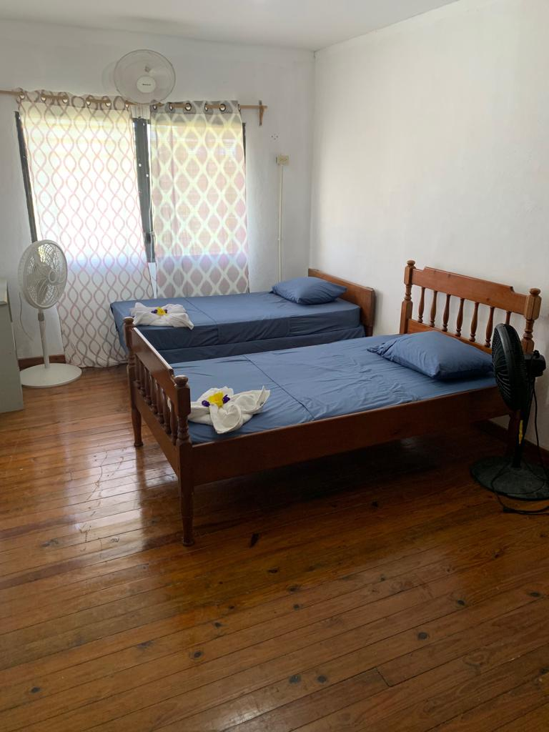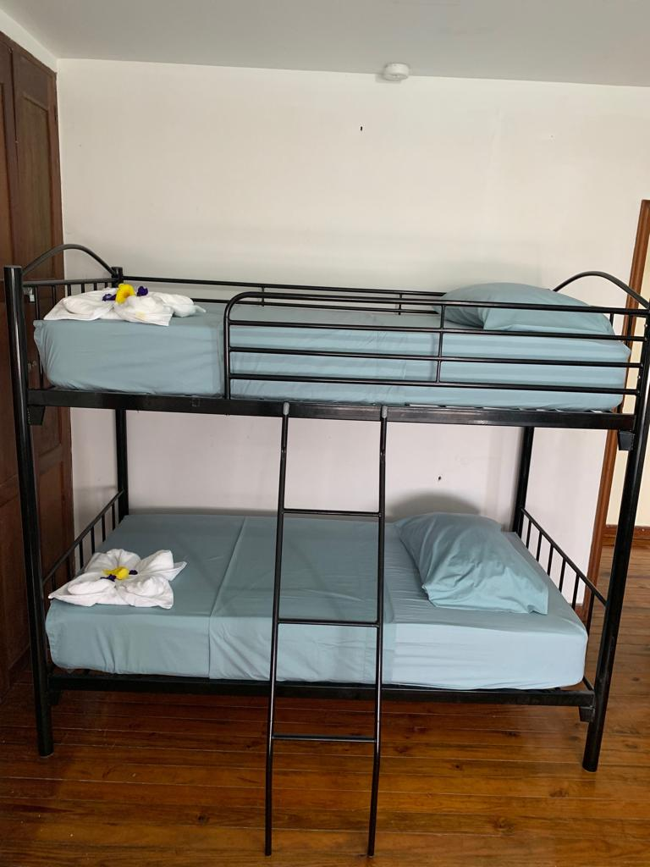
Capacity Building
Through collaboration with Massachusetts Audubon Society, and Dr. Bill Gette, four terrestrial rangers completed an Introduction to Ornithology training during the first quarter of 2019. The training was intended for conservationists, forest/park rangers, ecologists, environmental educators and included sessions on Sessions on Avian systematics, Taxonomy and Nomenclature.
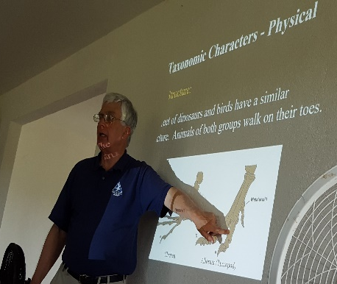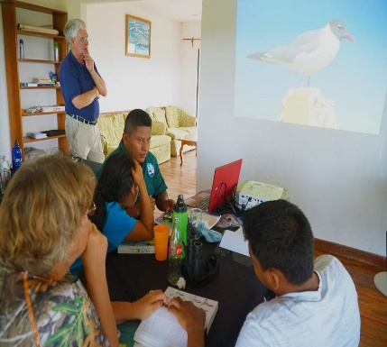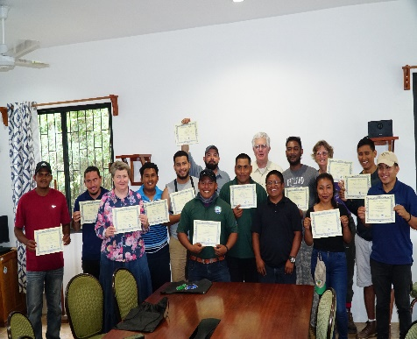

Biodiversity Monitoring Using Camera Trap
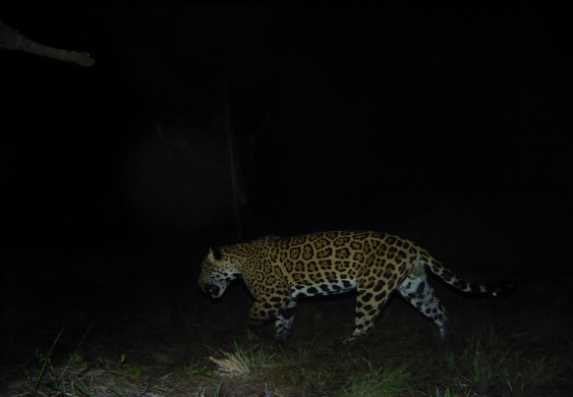
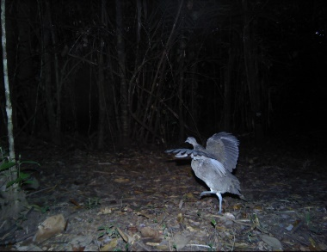
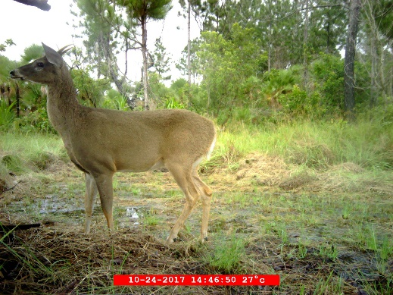
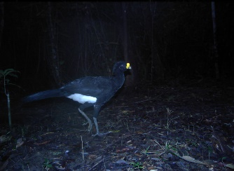
Aside from the birding course, rangers attended a planning meeting with Panther to learn about tagging images and basic maintenance of cameras used for biodiversity monitoring. During this period, TIDE had challenges with collecting regular data from cameras that were not functioning. After the cameras were returned to Panthera, they were not returned, so we intend to purchase our own cameras in 2020. Below are biodiversity data captured on cameras

Summary Table

Funds are in USD
Fund Data | 2002-2015 | 2016 | 2017 | 2018 | 2019 | Total
No. of proposals submitted | 32.00 | 2.00 | 1.00 | 3.00 | 4 | 42.00
No. of proposals approved | 32.00 | 2.00 | 1.00 | 3.00 | 4 | 42.00
Total approved funding for grants (TFCA Land Management account.) | 1,204,782.93 | 108,073.00 | 109,046.60 | 106,652.00 | 103,961.00 | 1,632,515.53
Total approved funding for grants (TFCA Land Purchase account.) | 667,500.00 | 0.00 | 0.00 | 0.00 | 0.00 | 667,500.00
Total approved funding for grants (TFCA Endowment account.) | 902,558.00 | 0.00 | 0.00 | 0.00 | 0.00 | 902,558.00
Total of counterpart match (grantee cost-share) | 0.00 | 0.00 | 0.00 | 0.00 | 0.00 | 0.00
Other leveraged matches (e.g. co-financing) | 267,532.61 | 4,825.00 | 0.00 | 89,800.00 | 42,631.13 | 404,788.75
Total matching funds as % TFCA Land Management grant | 22% | 4% | 0% | 84% | 41% | 25%
Amount spent on administrative costs | 316,684.32 | 27,018.25 | 27,261.65 | 26,663.00 | 25,990.00 | 397,627.22
Administrative costs as % of Land Management grants | 26% | 25% | 25% | 25% | 25% | 25%
Interest and capital gained on TFCA investments | 770,216.02 | 55,509.47 | 24,071.83 | 19,176.08 | 12,806.68 | 881,780.08
Fund balance at the end of the year (Endowment & Land Purchase accounts)* | 1,413,568.13 | 1,344,798.87 | 1,325,657.71 | 1,313,399.84 | 1,236,257.56 | 1,236,257.56

*Note: Amounts are determined on a cash basis.

