Port Honduras Marine Reserve:

2021 Queen Conch (Aliger gigas) Report

Prepared for

Toledo Institute for Development and Environment

1 Mile San Antonio Road

Punta Gorda Town, Toledo



December 2021

Funded by



**Introduction**

Queen conch (*Aliger gigas*) is another commercially important species fished within the Port Honduras Marine Reserve (PHMR). The populations of the queen conch within the PHMR are monitored annually through fishery independent surveys collected under the LAMP protocol in the PHMR, in southern Belize. This marine protected area was established in 2000 with an area of 40,468 Ha and co-managed by the Toledo Institute for Development and Environment (TIDE). The PHMR includes a range of ecosystems from coastal wetlands to mid lagoonal reefs (a unique reef type along the Belize Barrier Reef). It also contains extensive seagrass beds and surrounds over 100 mangrove cayes (Wildtracks 2017). It supports important artisanal commercial fisheries for spiny lobster and queen conch and serves as an important buffer between the southern mainland and the main barrier reef.

The focus of the PHMR is fisheries management with the majority of this marine reserve as a general use zone (95%) open to fishing. Four replenishment or no-take zones are designated (4%) around West, East and South Snake Cayes and West Cane Cayes, where non-extractive recreational activities are allowed. There is a preservation zone (1%), 0.8 km radius around Middle Snake Cayes, where only research activities are allowed (Figure 1) (Wildtracks 2017).

This report presents data collected in 2021 towards evaluating the management goal “*to return the abundance of commercial fishing species to sustainable levels by reducing pressure”*. The primary conservation target outlined in the current Management Plan for the PHMR, is that by 2020 the Fisheries Department and TIDE will identify and improve at least three responsible and effective fishing techniques in collaboration with PHMR fishers. The data from this report is intended to inform management of this nationally important fishery.



**Figure 1 PHMR Zones, from the PHMR Management Plan 2017-2021 (Wildtracks 2017)**

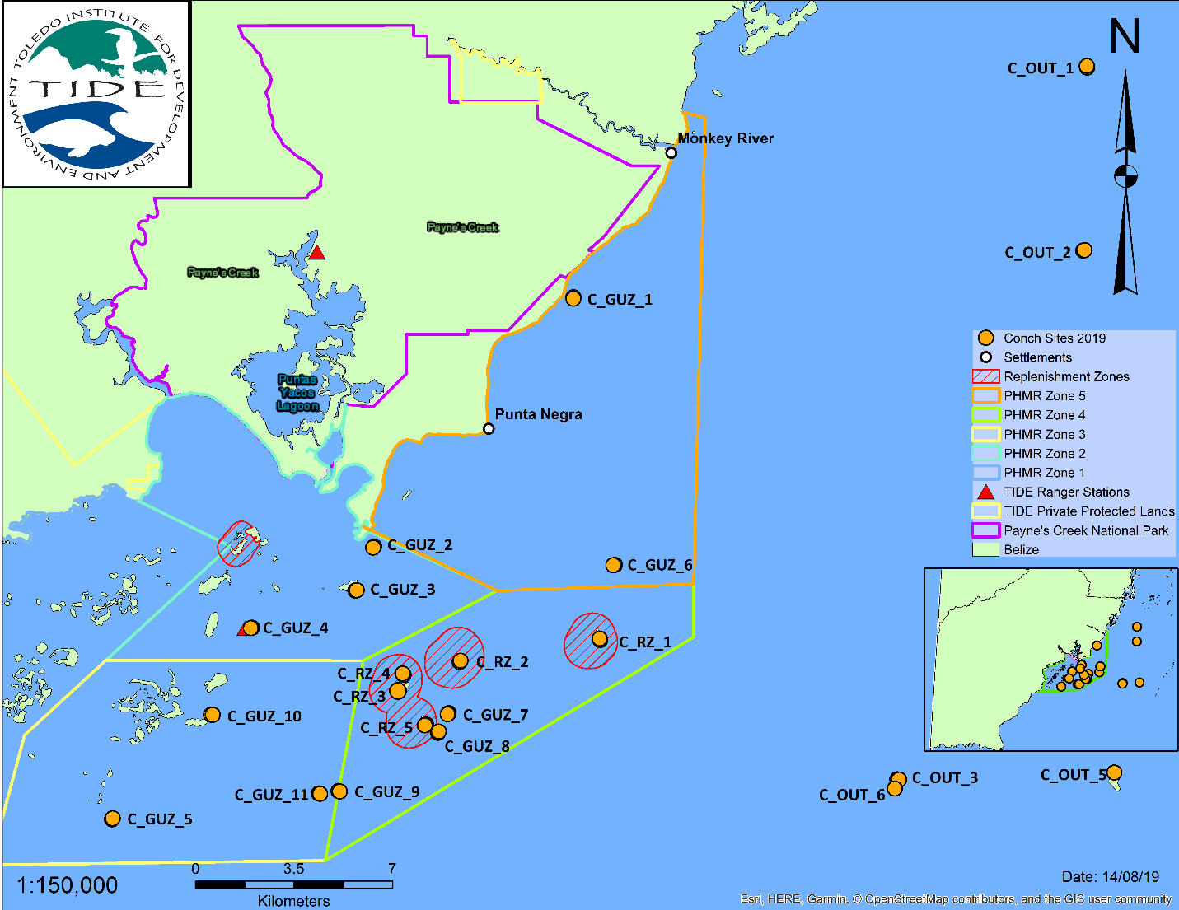

Figure Queen conch monitoring sites within the PHMR and adjacent buffer area (TIDE 2019)

**Methodology**

Since 2004 TIDE has been monitoring the populations of the commercially important species, queen conch (*Aliger gigas*), across twenty-one sites, both within the management zones of the marine reserve and outside, adjacent to the marine protected area (Figure 2). This long-term monitoring has produced information on population abundance, size and maturity of this important species. In 2021, TIDE completed annual monitoring of queen conch during July 4-7th, at the start of the closed season, and September 23rd to 29th, just before the open season (October 1st). Data was collected using previous methodology employed for queen conch, with five belt transects of 50 m by 4 m placed parallel to each other, for a total area of 1000 m2 per site. On each transect the entire 200 m2 area was searched and all conch encountered were counted and measured for shell length (SL), lip thickness (LT) and lip width (LW) (TIDE 2019). Only twenty sites out of the twenty-one were surveyed, 7 within the replenishment zones (RZ), 10 in the general use zones (GUZ) and 4 outside the reserve (OUT) (Figure 2). This report also compares data on mean abundance, mean shell length, mean lip thickness between May 2020 and July 2021, since data was only collected at the start of the closed season in May of 2020.

**Results**

A total of twenty out of twenty-one established monitoring sites were surveyed within the PHMR to assess the queen conch population in July and September 2021. In July, the site Bank 2 was not surveyed and in September, the site, South Snake Caye North, was not surveyed. Based on the surveys conducted, the mean density of queen conch in July was higher than September with 114 conch per Ha (±47.7 S.E.) vs. September, with 104 conch per Ha (±24.5 S.E.) (Table 1). Density fluctuated considerably among the sites with the highest being 970 conch per Ha in July and 390 conch per Ha in September. There were also less sites without conch in July (two sites) compared to four sites without conch in September. Mean shell length and mean lip thickness were smaller in July with 19 cm (±0.4 S.E.) and 2.9 mm (±0.9 S.E.), respectively, while in September mean shell length was 22.9 cm (±0.3 S.E.) and lip thickness was 5.4 mm (±1.1 S.E.) (Table 1). For both start of the closed season and end of the closed season, mean shell length exceeded the legal limit of 17.8 cm.

Across sites, September 2021 had slightly higher queen conch abundance with only 7 sites below 100 conch per Ha, while July 2021 had 11 sites with abundance below 100 (Figure 3). The highest abundances were at Flowers Bank in July, and Bank 2 and London Bank in September (Figure 3). At most sites, abundance was below 100 conch per Ha. Shell length varied slightly across the sites for both months. In July, four sites had a mean shell length below the legal limit of 17.8 cm, while in September 2021, for all sites, the mean shell length was above 17.8 cm (Figure 4). The largest size conchs were found at East Snake Bank, East Snake Caye, South Snake Caye and Flowers Bank in September 2021. The largest sizes during July were found at Middle Snake, Frenchman and South Snake Caye-North. When lip thickness was compared across sites for July and September, September generally had conch with larger lip thickness. There were more sites with lip thickness below 1 mm in July than in September, 8 sites versus 2 sites (Figure 5). Only one site in July 2021 had lip thickness above 10 mm (South Snake Caye) while three sites had lip thickness above 10 mm in September, with East Snake Caye having the largest lip thickness (Figure 5).

Size distribution analysis of shell length showed that the majority of conch was between 15.1 to 22.5 cm in July at the end of the open season, and at the end of the closed season (September) the majority were between 20.1 to 27.5 cm, indicating that September had larger conch than July (Figure 6A, B). Size distribution for lip thickness showed that for both July and September the majority of conch had no lip (Figure 7A, B). However, September had less conch without a flared lip and more conch with lip thickness 1-9 mm and >10mm (Figure B).

Queen conch abundance, shell length and lip thickness were compared across the management zones of the PHMR to present and highlight trends. Abundance was generally highest in the general use zone, followed by the replenishment zones then outside the reserve (Figure 8A). Densities at the start of the closed season (July) were higher than those at the end of the closed season (September) except for sites outside the marine reserve (8A). Shell length was fairly similar across the zones for both surveys, with the end of the closed season (September) having a larger mean shell length than the start of the closed season (July) (Figure 8B). Lip thickness varied across the zones with the largest lipped conchs in the replenishment zones, followed by the general use zone and then outside the marine reserve (Figure 8C). Once again, mean lip thickness was greater at the end of the closed season (September) than at the start of the closed season (July).

Lastly, data from 2020 was compared with this year, 2021. This was only a comparison between the start of the closed seasons for both years, since data was not collected for PHMR in September of 2020. There was more queen conch in 2021 than in 2020 at the end of the fishing or open season (Figure 9). Shell length was relatively the same between those two years, with lip thickness in 2021 being slightly less than 2020 (Figure 9).

Table 1 Summary of Shell Length (SL) in cm, Lip Thickness (LT) in mm, and Density (ha-1) from twenty-one long-term monitoring sites in the Port Honduras Marine Reserve.





Figure 3 Abundance of queen conch ha-1 at the twenty-one sites surveyed within the PHMR in 2021 (GUZ-General Use Zone, RZ-Replenishment Zone, OUT-Outside Reserve), at the start of the closed season (July 2021) and the end of the closed season (Sept 2021).



Legal size 17.8 cm

Figure 4 Mean shell length (SL) in cm of queen conch surveyed at sites within the PHMR (GUZ-General Use Zone, RZ-Replenishment Zone, OUT-Outside Reserve) (±Standard Error bars), at the start of the closed season (July 2021) and the end of the closed season (Sept 2021).



Figure 5 Mean lip thickness (LT) in mm of queen conch surveyed at sites within the PHMR (GUZ-General Use Zone, RZ-Replenishment Zone, OUT-Outside Reserve) (±Standard Error Bars), at the start of the closed season (July 2021) and the end of the closed season (Sept 2021). 

B

A

Figure 6A-B Size distribution of shell length (SL) in cm for all queen conch surveyed within the PHMR, (*A*) at the start of the closed season (July 2021) and (*B*) the end of the closed season (Sept 2021).



B

A

Figure 7A-B Size distribution of lip thickness (LT) in mm for all queen conch surveyed within the PHMR, (*A*) at the start of the closed season (July 2021) and (*B*) the end of the closed season (Sept 2021).

A

B

C

Figure 8A-C: Mean density per Ha (A), shell length in cm (B) and lip thickness in mm (C) of queen conch, among management zones of the PHMR (GUZ-General Use Zone, RZ-Replenishment Zone, OUT-Outside the Reserve) (±Standard Error Bars, S.E.), at the start of the closed season (July 2021) and the end of the closed season (Sept 2021).



Figure 9 Comparison of mean density per Ha, mean shell length in cm and mean lip thickness in mm of queen conch, between May 2020 and July 2021, (±Standard Error Bars, S.E.).

Discussion & Recommendations

Queen conch abundance in the PHMR has shown an improvement since 2020, with a 113% increase, however this is only for the start of the closed season, since data for both periods were not available in 2020. Nevertheless, this suggests a recovery of sorts of conch in PHMR. On more detailed analysis of the 2021 data, densities were lower in September at the end of the closed season or no fishing period, suggesting that conch numbers did not increase with the reduction in fishing pressure. Factors for this may be attributed to migration of conch from these sites to other parts of the marine reserve and illegal fishing during the closed season, especially from across the border. However, there was recovery in terms of population structure based on the larger sized conch and a greater proportion of adults being found at the end of the closed season, 8.3% in July at the start of the closed season and 16.3% by the end of the closed season. So, there is evidence that the closed season is providing an opportunity for conch to increase in size and maturity before fishing resumes. Conch size increased by 21% and there was approximately 100% more mature conch by September. This size at maturity is based on studies from both the PHMR and Glover’s Reef Marine Reserve that suggest 50% maturity occurs >10 mm, starting around 12-15 mm (Foley and Takahashi 2017, Tewfik *et al*., 2019).

Based on the current conch regulations, the size limit is a minimum shell length of 178 mm or 17.8 cm. According to the data collected at the start of the closed season, 63% of conch surveyed met this size limit but by the end of the closed season there had been an increase to 95% of conch meeting this size limit, indicating recovery at this level. There was therefore approximately 32% more conch available for harvest at the start of the fishing season in October. It is important to note, however, that of this legally harvestable quantity only 16.6% was adult conch (lip thickness >10 mm). Majority of the legally harvestable conch were still juveniles or sub-adults.

While queen conch densities in the PHMR have increased since 2020, there was still a large proportion of juveniles, conch without a flared lip, (57.1%) in September 2021, at the end of the closed season. The recommended density threshold for conch populations is 88 conch ha-1 (McDonald 2017), but as noted in the previous report, this is not the density necessary to overcome the “allee effect” since this includes all conch not just adults. The threshold for reproductive success is 50 adult conch ha-1 (Stoner *et al*. 2012b, Delgado and Glazer 2020). The current adult density in the PHMR at the end of the closed season was around 17.3 conch ha-1, based on 16.6% of the sample population being adults. As such, the queen conch population in the PHMR is made up mainly of immature individuals. With insufficient adult conch, the population’s ability to replenish itself and recover from sustained fishing pressure, is directly affected.

The management zones of the PHMR do not show a conclusive trend from year to year. In 2021, in terms of abundance, the general use zone had the most conch while the replenishment zones seemed to harbor conch with thicker flared lips. Whereas in 2020, the replenishment zones had both a higher conch abundance and conch with thicker flared lips. More conch in the general use zone is a desirable outcome given that this is the fishing zone for the marine reserve. There is some indication that the replenishment zones are functioning as a refugia, but it will require more monitoring over time to determine whether these zones are being effective in replenishing the fishery. Studies have shown that on average marine protected areas take up to ten years before any marked fisheries enhancement benefits are realized but can be as much as twenty years (Roberts *et al*. 2001, Huntington *et al*. 2011), for such increase in biomass, densities, reproductive output, among others (Roberts *et al*. 2001, Gell and Roberts 2003, Halpern 2003). As highlighted previously, these replenishment zones are very small and further assessment is necessary to determine an effective size to allow for fishery benefits (Halpern 2003). Expansion of these replenishment zones is a strategy that should be prioritized.

There is continuing evidence that the queen conch population in the Port Honduras Marine Reserve is overexploited given the low abundance and majority of immature individuals. However, a major data gap for adaptive management is still the lack of queen conch landings from the PHMR. This would provide more details on the mean shell length and lip thickness of conch harvested from the marine reserve and would provide an estimate of Catch Per Unit of Effort (CPUE), and relative abundance. Such landings data would also provide information on the total number of active fishers, average catch per fisher and conch production, which are all important data to determine the level of fishing effort within the marine reserve, a current gap. With this information more definitive strategies can be developed such as area specific quotas to ensure improved catch landings.

Management strategies need to incorporate the establishment of landing sites to collect data on shell length, lip thickness, dirty weight, market clean weight, gender and maturity (external morphology of sexual structures – verge and egg groove (Appeldoorn 1988, Buckland 1989)) so that the structure of the harvested portion of the population can be assessed on a long-term basis. This would allow for more accurate trends on how the fishery may be impacting the population, and thereby better inform adaptive management of queen conch fisheries within the PHMR. If time and resources allow, it would be useful to assess deeper waters (10-20 m) to determine whether there is a reproductive stock of spawning adults (>20 mm) within in the area, within suitable habitats such as such as sand channels or sandy areas with sparse seagrass and/or algae. This would help provide a better understanding of the source of conch recruits for the PHMR.

In summary, with data available on conch landings from an established data collection program, combined with the LAMP data, an annual catch quota for Fishing Area 5 (PHMR) can be developed to allow for more sustainable harvests based, thereby enabling the marine reserve to realize its management goal of a sustainable fishery through reduced fishing pressure. As has been recommended previously and supported by scientific publications within Belize and the region on conch maturity, the conch regulations should be revised to introduce a management measure for lip thickness at 50% maturity, >10 mm. Until these steps are taken the conch populations of the PHMR may continue to decline or experience reduced productivity.

**References**

Appeldoorn, R. S. 1988. Age determination, growth, mortality and age of first reproduction in adult queen conch, *Strombus gigas L*., off Puerto Rico. Fisheries Research, 6, 363–378. https://doi.org/10.1016/0165‐7836(88)90005‐7.

Buckland, B. J. 1989. Reproduction and growth of the queen conch, *Strombus gigas*, off St. Christopher and Nevis in the Eastern Caribbean. MSc thesis, University of Guelph, Guelph, Ontario.

Delgado, G. A., and Glazer, B. A. 2020. Demographics influence reproductive output in queen conch (*Lobatus gigas*): implications for fishery management. Bulletin of Marine Science, 96: https://doi.org/10.5343/bms.2019.0098.

Foley, J. R., and Takahashi, M. 2017. Shell lip thickness is the most reliable proxy to sexual maturity in queen conch (*Lobatus gigas*) of Port Honduras marine reserve, Belize; informing management to reduce the risk of growth overfishing. Frontiers in Marine Science, 4: 179.

Gell, F. R., & Roberts, C. M. 2003. Benefits beyond boundaries: The fishery effects of marine

reserves. *Trends in Ecology and Evolution*, *18*(9): 448–455. https://doi.org/10.1016/S01695347(03)00189-7.

Halpern, B. S. 2003. The impact of marine reserves: do reserves work and does reserve size matter? *Ecological Applications*, *13* (sp1), 117–137.

Huntington, B. E., Karnauskas, M., & Lirman, D. 2011. Corals fail to recover at a Caribbean marine reserve despite ten years of reserve designation. *Coral Reefs*, *30*(4), 1077–1085. https://doi.org/10.1007/s00338-011-0809-4.

McDonald, G., et al. 2017. An indicator-based adaptive management framework and its development for data-limited fisheries in Belize. Marine Policy, 76: 28 - 37.

Roberts, Callum M, Bohnsack, J. A., & Gell, Fiona, Hawkins, Julia P, Goodridge, R. 2001. *Effects of Marine Reserves on Adjacent Fisheries*. *294* (November), 1920–1924.

Stoner, A. W., Davis, M. H., and Booker, C. J. 2012b. Negative consequences of Allee effect are compounded by fishing pressure: Comparison of queen conch reproduction in fishing grounds and a marine protected area. Bulletin of Marine Science, 88: 89-104.

Tewfik, A., Babcock, E. A., Appeldoorn, R., and Gibson, J. 2019. Declining size of adults and juvenile harvest threatens sustainability of a tropical gastropod, Lobatus gigas, fishery. Aquatic Conservation: Marine and Freshwater Ecosystems, DOI: 10.1002/aqc.3147.

Toledo Institute for Development and Environment. 2019. Port Honduras Marine Reserve Benthic Commercial Species Update 2019. 35 pp.

Wildtracks. 2017. Port Honduras Marine Reserve - Management Plan 2017-2021. 236 pp.