Port Honduras Marine Reserve:

Spiny lobster Report

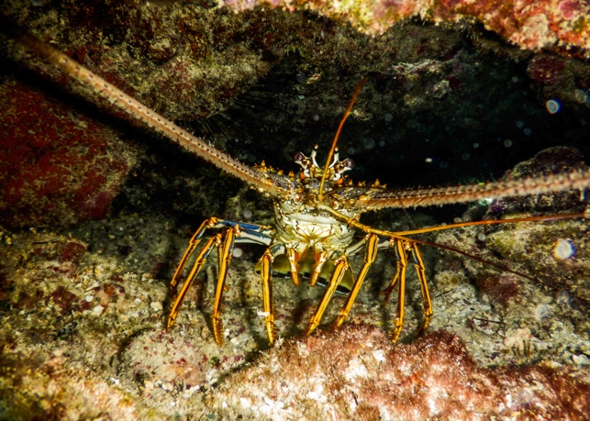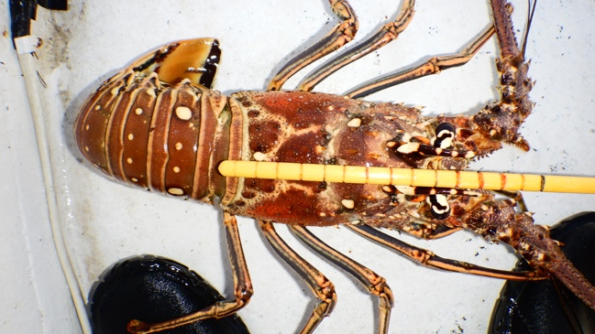2021

Prepared for

Toledo Institute for Development and Environment

1 Mile San Antonio Road

Punta Gorda Town, Toledo



November 2021

Funded by



**Introduction**

Spiny Lobster (*Panulirus argus*) is a major commercially important species fished within the Port Honduras Marine Reserve (PHMR). The populations of the spiny lobster within the PHMR are monitored annually through fishery independent surveys collected under the LAMP protocol in the PHMR, in southern Belize. This marine protected area was established in 2000 with an area of 40,468 Ha and co-managed by the Toledo Institute for Development and Environment (TIDE). The PHMR includes a range of ecosystems from coastal wetlands to mid lagoonal reefs (a unique reef type along the Belize Barrier Reef). It also contains extensive seagrass beds and surrounds over 100 mangrove cayes (Wildtracks 2017). It supports important artisanal commercial fisheries for spiny lobster and queen conch and serves as an important buffer between the southern mainland and the main barrier reef.

The focus of the PHMR is fisheries management with the majority of this marine reserve as a general use zone (95%) open to fishing. Four replenishment or no-take zones are designated (4%) around West, East and South Snake Cayes and West Cane Cayes, where non-extractive recreational activities are allowed. There is a preservation zone (1%), 0.8 km radius around Middle Snake Cayes, where only research activities are allowed (Figure 1) (Wildtracks 2017).

This report presents data collected in 2021 towards evaluating the management goal “*to return the abundance of commercial fishing species to sustainable levels by reducing pressure”*. The primary conservation target outlined in the current Management Plan for the PHMR, is that by 2020 the Fisheries Department and TIDE will identify and improve at least three responsible and effective fishing techniques in collaboration with PHMR fishers. The data from this report is intended to inform management of this nationally important fishery.



Figure PHMR Zones, from the PHMR Management Plan 2017-2021 (Wildtracks 2017)

**Methodology**

Since 2004 TIDE has been monitoring the populations of the commercially important species, spiny lobster (*Panulirus argus*), across twenty-one sites, both within the management zones of the marine reserve and outside, adjacent to the marine protected area (Figure 2). This long-term monitoring has produced information on population abundance, population structure, size and reproductive state of this important species. In 2021, TIDE completed surveys at these long-term monitoring sites during mid-March 2021, at the start of the closed season and in mid-June 2021 at the end of the closed season. Data was collected using previous methods for spiny lobster population surveys, that of timed swims to estimate abundance with catch per unit effort (CPUE) estimates. At each site, two divers swam and searched reef patches for approximately 30 minutes. The actual survey time for individual sites varied between 28-47 minutes based on size of the area. For each lobster caught or found, the species, carapace length (CL) and gender were determined by visual examination, where it was possible to capture the lobster without harm (TIDE 2019). Females were checked for the presence of eggs and tar spots. During March 2021, nineteen out of twenty-one sites were surveyed. In June 2021, twenty sites were surveyed. In total, there were 8 within the replenishment zones (RZ), 9 in the general use zone (GUZ) and 4 outside the marine reserve (OUT) (Figure 2). This report also compares data on mean CPUE and mean size between 2020 and 2021.

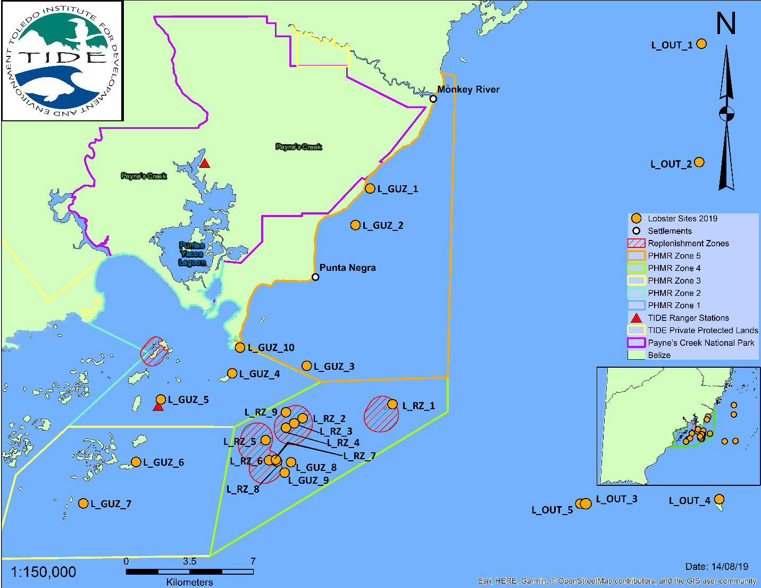

Figure Spiny lobster monitoring sites within the PHMR and adjacent buffer area (TIDE 2019)

**Results**

In 2021, the Ministry of Blue Economy, through the Fisheries Department, amended the closed season for spiny lobster and shifted it from February 15th - June 14th of every year; to March 1st - June 30th, annually. Summary data for population metrics on mean size, mean catch per unit of effort (CPUE), sex ratio, and reproductive state were determined and are presented below. The mean CPUE for spiny lobster at the start of the closed season was 3.1 lobsters per hour (±0.7 S.E.) and by the end of the closed season it was 4.8 lobsters per hour (±0.9 S.E.). The mean size at the start of the closed season was 7.3 cm (±0.5 S.E.) and at the end of the closed season the mean size was 8.4 cm (±0.3 S.E.) (Table 1). CPUE ranged from 0.0 to 13.4 lobsters per hour, while mean size ranged from 4.0 to 10.7 cm (Table 1).

On average, the abundance of spiny lobsters in the PHMR was low, with some increase in abundance seen at the end of the closed season. Of the nineteen sites surveyed in March 2021, at the start of the closed season, two did not have any lobsters recorded, Bank 1 and East South Snake Caye. Wilson Caye had the highest CPUE with 13.4 lobsters per hour (Figure 3). In June 2021, at the end of the closed season, twenty sites were surveyed with 3 sites having no lobsters: Middle South Bank, South Snake Caye and West Snake Caye (Figure 3). The highest CPUE recorded in June 2021 was 12.5 lobsters per hour.

When CPUE was compared among management zones, the general use zone had the highest CPUE in both March and June 2021. In March 2021, the CPUE for the replenishment zones and buffer zones (outside the PHMR) were the same, while CPUE within the replenishment zone was slightly higher than at sites outside the marine reserve in June 2021 (Figure 4).

Mean size, measured as carapace length, was compared among sites for both March and June 2021. At the start of the closed season, in March 2021, ten sites had a mean lobster size that was less than the legal size of 7.6 cm (Figure 5). While at the end of the closed season, June 2021, six sites had mean size below the legal limit (Figure 5). The smallest mean sizes were found at Abalone Caye and Copper Bank in March, and at Middle Snake Caye and LOB (OUT 4) in June (Figure 5).

Among the management zones, mean size increased from the start of the closed season to the end of the closed season, just before the lobster season opened in July 2021. In March 2021, mean size increased across zones, with the general use zone having the smallest lobsters, followed by the replenishment zones with slightly larger lobsters, and then outside the marine reserve having the largest lobsters (Figure 6). In June 2021, the mean size was fairly similar across the management zones, between 8.2 and 8.5 cm (Figure 6).

Mean lobster size was also compared by gender for both seasons. Female lobsters had similar sizes at the start and end of the closed season, 7.5 and 7.4 cm respectively, but male lobsters showed an increase in size from the start of the closed season (March), 7.3 cm to the end of the closed season (June), 8.8 cm, Figure 7.

The size frequency of lobsters was compared between the start of the closed season and end. In March, at the start of the closed season, only 51% of lobsters observed were above the legal-size limit of 7.6 cm. By the end of the closed season in June, this showed a slight increase with 58% of lobsters being over the legal-size limit (Figure 8). This means on average a little over half of the lobsters (55%) from either season were ready to be harvested.

From the surveys, in March 2021 there were more females present than males, 65% to 35%. In June the sex ratio was more balanced with 51% females to 49% males (Figure 9). In terms of reproductive state of the females, very few displayed tar spots or had eggs. In March 2021, 13% of the twenty-three females found had eggs and none had tar spots. In June 2021, 1.7% of the fifty-eight females found had tar spots and none had eggs (Figure 10).

Data on mean abundance (CPUE) and mean size (carapace length) across the management zones were compared with 2020 to note any trends from the previous year. While there were no clear trends in abundance with management zones between the two years, mean CPUE showed major changes from one year to the next, with abundance being much greater in 2021 than in 2020 (Figure 11). The difference between the end of the closed seasons (May/June) was even higher than that at the end of the open season (February/March). Mean CPUE at the end of the open season in 2020, ranged between 0.8-1.2 across the zones, and in 2021 it ranged from 2.7-3.7 (Figure 11). While at the end of the closed season, in 2020, it had marginally increased ranging from 1.3-2.0; in 2021 the mean CPUE ranged from 4.1-5.2, which represented a large increase from this year’s end of the open season, and an even more significant increase over 2020 (Figure 11). Mean size across the management zones did not vary greatly between the two years but in general, sites within replenishment zones and buffer areas outside the marine reserve had larger sized lobsters (Figure 12).

Table 1 Summary of Catch Per Unit of Effort (CPUE: # lobsters hr-1) and Mean Carapace Length (CL) in cm, from twenty-one monitoring sites in the Port Honduras Marine Reserve.



Figure 3 Spiny lobster CPUE from twenty-one sites within the PHMR and adjacent buffer area, during March 2021 at the start of the closed season; and June 2021 at the end of the closed season.

Figure 4 Spiny lobster CPUE within the management zones of the PHMR; GUZ – General Use Zone, RZ - Replenishment Zone and OUT – outside the reserve/buffer area (±Standard Error bars), at the start of the closed season (March 2021) and the end of the closed season (June 2021).

Legal size 7.6 cm

Figure 5 Spiny lobster mean size (carapace length) from twenty-one sites within the PHMR, at the start of the closed season (March 2021) and the end of the closed season (June 2021); (±Standard Error Bars).

Figure 6 Mean size of spiny lobster within the management zones of the PHMR; GUZ – General Use Zone, RZ - Replenishment Zone and OUT – outside the reserve/buffer area (±Standard Error bars), at the start of the closed season (March 2021) and the end of the closed season (June 2021).

Figure 7 Spiny lobster mean size (carapace length) for females and males within the PHMR (±Standard Error bars), at the start of the closed season (March 2021) and the end of the closed season (June 2021).



Legal size 7.6 cm



Legal size 7.6 cm

Figure 8 Size frequency of spiny lobsters from within the PHMR at the start of the closed season (March 2021) and the end of the closed season (June 2021).

Figure 8 Size frequency of spiny lobsters from within the PHMR at the start of the closed season (March 2021) and the end of the closed season (June 2021).

Figure 8 Size distribution of spiny lobsters based on carapace length at the start of the closed season (March 2021) and the end of the closed season (June 2021).



Figure 9 Spiny lobster sex ratio within the PHMR at the start of the closed season (March 2021) and the end of the closed season (June 2021).



Figure 10 Reproductive state of female spiny lobsters within the PHMR at the start of the closed season (March 2021) and the end of the closed season (June 2021).

Figure 11 Comparison of mean CPUE (# lobsters per hour) within PHMR management zones between 2020 and 2021 (±Standard Error Bars); (Feb 2020 and Mar 2021 - start of the closed season, May 2020 and Jun 2021 - end of the closed season).

Figure 12 Comparison of mean size (cm) within PHMR management zones between 2020 and 2021 (±Standard Error Bars); (Feb 2020 and Mar 2021 - start of the closed season, May 2020 and Jun 2021 - end of the closed season).

**Discussion & Recommendations**

As expected, there was some recovery of the spiny lobster population in the closed season evidenced by the abundance (CPUE) and size showing a small increase by June 2021, just before the open season of July 1st. While abundance did not show a large increase (3.1 to 4.8 lobsters per hour), the mean size did increase considerably, going from below the legal-size limit to above. This type of response, in abundance and size, is commonly seen with a reprieve from fishing through removal of fishing pressure during closures. This year’s data did show a very clear trend of greater abundance within replenishment zones as last year’s data did, with the general use zone having the highest abundances. The management team will need to take a closer look at patrols and enforcement records to ensure effective functioning of these zones, but also conduct a proper habitat characterization of the monitoring sites with regards to suitability as lobster habitat.

Overall, the abundance of spiny lobsters in the PHMR has increased since 2020, based on CPUE comparisons for the end of the open season and end of the closed season. While 2021 showed an increase in abundance of lobsters, this was still fairly low abundance. This change from year to year may be due to a variety of reasons including timing of recruitment and lobster movement across areas, changes in fishing activities, whether areas are primary lobster habitat or fishing grounds, and annual variation in recruitment rates (Acosta, 1999; Acosta 2002, Acosta and Robertson, 2003). Abundance also varies based on habitat complexity with more complex habitats providing greater spaces for lobsters (Acosta, 1999; Acosta 2002). There is also well-established information that shows that larger lobsters (adults) prefer reef areas over seagrass habitats and that they move between shallow and deep habitats throughout the year (Acosta, 1999; Acosta 2002; Acosta and Robertson, 2003).

Based on data on mean size from the start of the closed season to the end of the closed season, the lobster fishery closure seems to be working effectively to allow for some recovery in the size of lobsters and in particular the male lobsters, that due to their larger size, are more heavily targeted. Males were much larger near the end of the closed season at mean size of 8.8 cm (±0.3 S.E.) which is above the legal-size limit, with fewer sites having undersized lobsters in mid-June 2021. In regards to lobster size, the replenishment and buffer areas appear to be functioning as refuges for the larger lobsters during the fishing season, since there were larger lobsters in these areas in March and by June all zones had similar sizes of lobsters after recruitment and growth took place. However, when the population was examined with respect to size structure, only a little over half of the lobsters found were large enough to be harvested, which presents a concern in regards to sustainable fishing, since there was not a high abundance of legally size lobsters for harvesting from these sites. Unless the areas where shades and traps are placed have a greater abundance of legally size lobsters, this presents a challenge for the fisheries. Comparison with 2020’s data on size did not show any major difference in size from year to year, with a mean of 8.4 cm in 2020 and 7.9 cm in 2021

It must be taken into consideration, that similar to 2020’s data, it is likely that only a portion of these legally sized lobsters are sexually mature, based on recent studies cited from the region suggesting that size at maturity is between 7.9-8.9 cm for females (Ehrhardt, 2005; Cruz and Bertelsen, 2008). Closer to home, a long-term study on lobsters in Glover’s Reef and South Water Caye (Tewfik *et al*., 2020), suggests that 50% size at maturity occurs between at 9.8 cm for males and 8.6 cm for females. When this is factored in, only 23% of males and 11% of females would be sexually mature from among those that were legally ready for harvest at the end of the closed season (June).

Further evidence for recovery during the closed season can be seen in relation to the sex ratio. Since males are larger and more highly targeted, there was a lower proportion of males at the start of the closed season in March but by end of the closed season, with time for the population to recover without fishing, the sex ratio had become relatively balanced (51%:49%). There was some indication that reproduction was still underway in mid-June based on a few lobsters being found with a tar spot, but this may have been the late reproducers since it was only 1.7% of lobsters found with tar spots. It is likely that by July 1st, eggs would have been laid and these berried females are protected under the law. The closed season doesn’t protect year-round breeding but may only allow for recolonizing of shallow habitats by lobsters from deeper reefs (Acosta and Robertson, 2003).

TIDE’s personal communication based on anecdotal information, indicates that fishers harvest spiny lobsters from seagrass habitats using traps and is the major method of harvesting used for this fishery. TIDE reported that shades are usually placed outside the reserve along banks and inside the reserve on seagrass flats, with some informal territorial access by Monkey River fishers in the northern part of the PHMR. Given this practice and the large gap in lobster catch data, TIDE needs to immediately conduct a full inventory of lobster fishing, number of fishers, gear and fishing areas within the PHMR and adjacent area. Without this information, continued monitoring of only these patch reefs among the various zones will not provide a complete representation of the population status. As noted, there is some recovery of the population during the closed season. Lobsters may be moving from deeper habitats to shallow patch reefs during the closed season under the shield of protection from fishing and may also migrate out the replenishment zones into fished areas (Acosta and Robertson, 2003).

In summary, the 2021 monitoring data shows an increase in the abundance of spiny lobster for the Port Honduras Marine Reserve since last year, however this number is still low and only a little more than half of the lobsters meet legal size of 7.6 cm at the end of the closed season. In addition, based on recent studies, only there is only a small proportion of lobsters that are sexually mature. This suggests that the population is not recovering adequately and may be fully exploited approaching overexploitation. There needs to be an assessment of annual fishing effort and production to inform the level of fishing in the area, and a consideration of the introduction of a quota for the marine reserve.

It is crucial that the recommendation from last year for establishment of fishery dependent monitoring of the spiny lobster population, be implemented for 2022. When this data is available, a more complete picture of the state of the spiny lobster population in the PHMR can be established and more effective management actions taken. Regular fisheries independent monitoring, using LAMP protocol, of spiny lobsters should be continued but sites need to be included in areas where traps and shades are used to assess the population there and ensure that habitats are properly characterized.

**References**

Acosta, C.A. 1999. Benthic dispersal of Caribbean spiny lobsters among insular habitats: implications for the conservation of exploited marine species. Conserv Biol 13:603–612.

Acosta, C.A. 2002. Spatially explicit dispersal dynamics and equilibrium population sizes in marine harvest refuges. ICES J Mar Sci 59:458–468.

Acosta, C.A., Robertson, D.N. 2003. Comparative spatial ecology of fished spiny lobsters *Panulirus argus* and an unfished congener *P. guttatus* in an isolated marine reserve at Glover’s Reef atoll, Belize. Coral Reefs 22: 1–9.

Cruz, R., Bertelsen, R. D. 2008. The Spiny Lobster (*Panulirus argus*) in the Wider Caribbean: A Review of Life Cycle Dynamics and Implications for Responsible Fisheries Management. Proceedings of the 61st Gulf and Caribbean Fisheries Institute, ﻿pp 433-446.

Ehrhardt, N.M. 2005. Population dynamic characteristics and sustainability mechanisms in key Western Central Atlantic Spiny Lobster, *Panulirus argus*, fisheries. Bulletin of Marine Science, 76(2): 501–525.

Tewfik, A., Babcock, E.A., Phillips, M. 2020. Spiny lobster fisheries status across time and a mosaic of spatial management regimes. ICES Journal of Marine Science, doi:10.1093/icesjms/fsaa008.

Toledo Institute for Development and Environment. 2019. Port Honduras Marine Reserve Benthic Commercial Species Update 2019. 35 pp.

Wildtracks. 2017. Port Honduras Marine Reserve - Management Plan 2017-2021. 236 pp.