Port Honduras Marine Reserve:

Donkey Dung Sea Cucumber

(Holothuria mexicana)

Population Assessment

2020-21

Prepared for

Toledo Institute for Development and Environment

1 Mile San Antonio Road

Punta Gorda Town, Toledo



December 2021

Funded by



**Introduction**

In Belize, the donkey dung sea cucumber (Holothuria mexicana) is an important, commercially fished species, primarily for export, since 2009 (Perez and Garcia 2012). It is the most abundant of the 49 species of sea cucumbers found in Belize (Rogers 2013). In the Port Honduras Marine Reserve (PHMR), the donkey dung sea cucumber gained commercial importance and was targeted at increasing levels from 2011 (TIDE 2019). This species has been fished for two decades to supply regional markets in Guatemala and a local Asian market in Belize. However, fishing for export to international markets started in 2009 (Rogers et al. 2018). With the advent of this export market, by 2016 the donkey dung sea cucumber was considered overfished across Belize and including the PHMR. This population decline warranted a national moratorium on sea cucumber fishing which was implemented in 2017, by the Belize Fisheries Department. This moratorium was lifted after four years in May 2020, with a fishing season from May 11 to June 30, with the expectation that population numbers had rebound. The season was open again this year for a longer period, from March 15 to June 30, 2021 (press release Belize Fisheries Department, 2021). Sea cucumbers are currently regulated through a closed season, minimum size and minimum weight.

The PHMR was established in 2000 with an area of 40,468 Ha and co-managed by TIDE. The PHMR includes a range of ecosystems from coastal wetlands to mid lagoonal reefs (a unique reef type along the Belize Barrier Reef). It also contains extensive seagrass beds and surrounds over 100 mangrove cayes (Wildtracks 2017). It supports important artisanal commercial fisheries for spiny lobster and queen conch and serves as an important buffer between the southern mainland and the main barrier reef.

The main purpose of the PHMR is fisheries management with the majority of this marine reserve as a general use zone (95%) open to fishing. Four replenishment or no-take zones are designated (4% total) around West, East and South Snake Cayes and West Cane Cayes, where non-extractive recreational activities are allowed. There is a preservation zone (1%), 0.8 km radius around Middle Snake Cayes, where only research activities are allowed (Figure 1) (Wildtracks 2017).

This report presents data collected over two years, 2020-2021, towards evaluating the management goal “to return the abundance of commercial fishing species to sustainable levels by reducing pressure”. The primary conservation target outlined in the current Management Plan for the PHMR, is that by 2020 the Fisheries Department and TIDE will identify and improve at least three responsible and effective fishing techniques in collaboration with PHMR fishers. The data from this report is intended to inform the status of the population of donkey dung sea cucumbers, that has been closed to fishing since 2017.



**Figure 1 PHMR Zones, from the PHMR Management Plan 2017-2021 (Wildtracks 2017)**

**Methodology**

The Toledo Institute for Development and Environment (TIDE) has been monitoring the populations of donkey dung sea cucumber since 2011 using fishery independent surveys. Monitoring continued through the years of the moratorium, so there is annual assessment of the population available to observe population trends during the closure of the fishery. This report looks at data from 2020 and 2021. Data from previous years, 2017-2019 will be used to compare and look for any signs of a population recovery within the PHMR.

Donkey dung sea cucumbers (Holothuria mexicana) were surveyed using a visual census technique within a 400 m2 circular area, based on methods from Amesbury and Kerr (1996). At each location, two permanent marker pins have been placed underwater using PVC pipes with a concrete base. A pair of divers surveyed the site by placing a tape measure at the first marker and slowly swimming in a circle with the tape measure attached for a radius of 11.28m. The divers swim inner circles at 3m, 6m, 9m and 11.28m distance from the marker, to cover the entire area within the 11.28m radius. A second transect is repeated at 25 m away at the second point. This results in a 400m2 area surveyed per transect. Each site had two transects completed. Once a sea cucumber is found, its position on the transect is recorded along with its length and width, the depth at which it was found and the substrate type where it was found. When measurements are completed, the sea cucumber is collected to take to the surface at the end of the transect survey. At the surface the samples are weighed and then placed back in the water.

A total of twenty-two sites were surveyed in 2020 and twenty-three in 2021, within the replenishment zones, general use zone and outside the reserve (Figure 2). Surveys were conducted over 3-4 days during May 2020 and July 2021. Data on abundance (density), length, width, and weight are presented here.

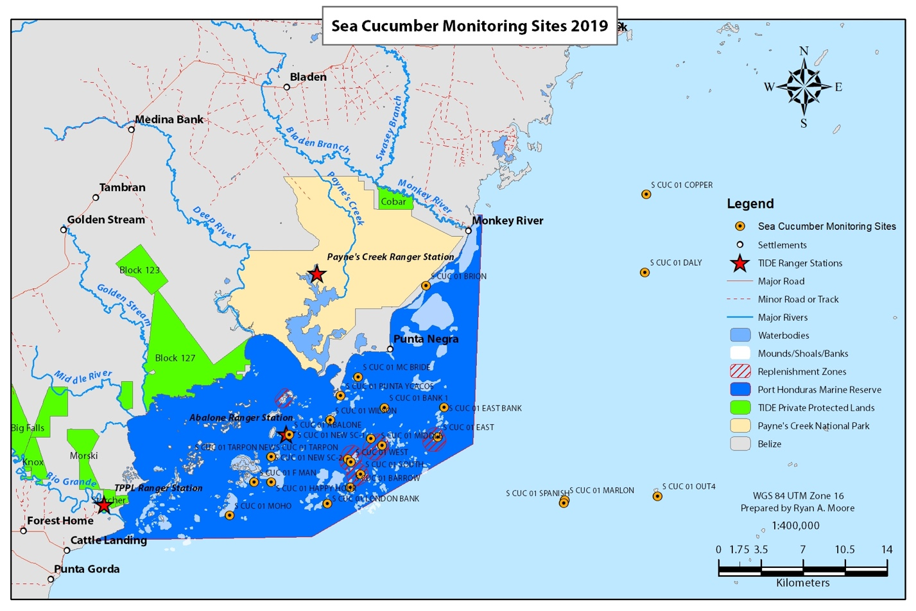

Figure 2 Sea cucumber monitoring sites within the PHMR and adjacent buffer area (TIDE 2019)

**Results**

Donkey dung sea cucumbers were surveyed in 2020 and 2021 from twenty-four established monitoring sites in the PHMR. Overall population abundance was very low with a mean of 14.2 per ha and 21.7 per ha of sea cucumbers, in 2020 and 2021 respectively (Table 1). Only six of the 22 sites surveyed in 2020 and 9 of the 23 sites surveyed in 2021, had sea cucumbers (Table 1). The mean length, width and weight of sea cucumbers in 2020 was 22.2 (±2.0 S.E.) cm, 0.9 (±0.2 S.E.) cm, 0.6 (±0.1 S.E.) kg, and was similar in 2021, with 23.7 (±1.9 S.E.) cm, 0.6 (±0.1 S.E.) cm, 0.5 (±0.1 S.E.) kg, respectively (Figure 3, Table 1).

Across sites, the density of sea cucumbers varied from 0 to 87.5 per ha in 2020, and from 0 to 112.5 per ha in 2021 (Figure 4). For both years, Bank 1 and East Snake Bank sites had the highest densities, while in 2020, Abalone Caye had one of the highest densities, and in 2021, Punta Ycacos also had one of the highest densities of sea cucumbers (Figure 4). In 2020, 7 of the 12 general use zone sites, 4 of the 5 replenishment zones and all 5 of the outside sites, had no sea cucumbers (Figure 4). In 2021, only 3 of the 12 general use zone sites had no sea cucumbers, while all replenishment zones and all outside sites, had no sea cucumbers (Figure 4).

Sea cucumber length, width and weight showed slight variation across the sites. Length ranged from 20.2 to 24.9 cm, width ranged from 0.5 to 2.1 cm and weight ranged from 0.5 to 0.8 kg, in 2020 (Figures 5-7). For 2021, length was slightly higher, ranging from 21.0 to 26.5 cm (Figure 5). Width was slightly smaller, ranging from 0.4 to 0.7 cm, and weight was also slightly lower ranging from 0.3 to 0.7 kg (Figures 6-7). The largest sea cucumbers were found at Bank 1 and East Snake Bank for both years (Figure 5). Width and weight fluctuated across the sites, with Bank 1 and East Snake Bank having higher width and weight than the other sites, but New SC-1 and West Snake Bank also had among the higher widths (Figure 6-7).

Based on the sea cucumber regulations, there is a minimum length of 10 inches (25.4 cm) OR a minimum weight of 7 ounces (0.2 kg), that donkey dung sea cucumber must reach in order to be harvested. None of the sites in 2020, had mean sea cucumber length of 25.4 cm, and in 2021, only three sites did (Bank 1, East Snake Bank and Tarpon) (Figure 5). Whereas all sites had sea cucumbers with a mean weight that met the legal weight limit of 0.2 kg (Figure 7) for both years.

The size frequency of donkey dung sea cucumbers was analyzed and frequency distribution graphs prepared. Using length (cm), the majority of sea cucumbers (64% in 2020 and 80% in 2021) were between 18 to 28 cm in length (Figure 8a). In terms of weight (kg), the majority of sea cucumbers (92% in 2020 and 95% in 2021) were between 0.3 to 0.9 kg in weight (Figure 8b).

The mean density, length, width and weight were assessed for each management zone for 2020 and 2021. As noted, prior, majority of the sea cucumbers were located within the general use zone of the marine reserve for both years (Figure 9a). There was only one site out of the five replenishment zone sites monitored, that had sea cucumbers for 2020. And no sites outside the marine reserve had any sea cucumbers. Density in 2021 was higher than density in 2020. Mean length was greater in the general use zone than the replenishment zone (Figure 9b) and slightly higher in 2021 than in 2020. Mean width was higher in 2020 than 2021 and higher in the replenishment zone than the general use zone (Figure 9c). Mean weight was also higher in 2020 than in 2021 (Figure 9d).

Mean density, length and weight of donkey dung sea cucumbers were compared for the zones of the PHMR from 2017 to 2021. Mean density in the general use zone has shown an increase over the years with the highest density encountered in 2021 of 42.0 per ha (±10.4 S.E.) (Figure 10a). However, the trend is reversed for the replenishment zones, with a decrease in abundance over the years and the lowest density found in 2021, 2.5 per ha (± 2.5 S.E.). Generally, sea cucumbers were rarely found at sites outside the reserve and only in 2018 (Figure 10a). Mean length was generally similar among the general use and replenishment zones over the years from 2017 to 2021, ranging between 21 to 25 cm with the exception of the year 2019, when mean length in the general use zone was 28 cm (Figure 10b). In 2018, the only year that had sea cucumbers outside the reserve, had the largest with a mean length of 33 cm (Figure 10b). Mean weight over the period 2017 to 2021 showed a general declining trend, from 0.7 to 0.5 kg in the general use zone and 0.8 to 0.6 kg in the replenishment zone (Figure 10c). In 2018, outside the reserve, the mean weight was the highest observed during the five years, with a mean of 1.6 kg.

Table 1 Summary of Mean Length (cm), Mean Width (cm), Mean weight (kg) and Density (ha-1) of donkey dung sea cucumber from twenty-four long-term monitoring sites in the Port Honduras Marine Reserve.





Figure 3 Mean length (cm), mean width (cm) and mean weight (kg) of donkey dung sea cucumber from all sites within the PHMR for 2020 and 2021 (±Standard Error bars).



Figure 4 Abundance of donkey dung sea cucumber ha-1 at the twenty-four sites surveyed within the PHMR in 2020 and 2021 (GUZ-General Use Zone, RZ-Replenishment Zone, OUT-Outside Reserve).



Figure 5 Mean length (cm) of donkey dung sea cucumber surveyed at sites within the PHMR (GUZ-General Use Zone, RZ-Replenishment Zone, OUT-Outside Reserve) (±Standard Error bars) in 2020 and 202; red line indicates the minimum size limit of 25.4 cm for legal harvesting.



Figure 6 Mean width (cm) of donkey dung sea cucumber surveyed within the PHMR (GUZ-General Use Zone, RZ-Replenishment Zone, OUT-Outside Reserve) (±Standard Error Bars) in 2020 and 2021.



**Figure 7 Mean weight (kg) of donkey dung sea cucumber surveyed at sites within the PHMR (GUZ-General Use Zone, RZ-Replenishment Zone, OUT-Outside Reserve)** **(±Standard Error bars) in 2020 and 2021; red line indicates the minimum weight limit of 0.2 kg for legal harvesting.**

8a 8b

Figure 8a: Size frequency distribution of donkey dung sea cucumber in the PHMR in 2020 and 2021, and 8b: weight frequency distribution of donkey dung sea cucumber in the PHMR in 2020 and 2021.



9a 9b

9c 9d

Figure 9a-d: Mean density per ha (a), length in cm (b), width in cm (c) and weight in kg (d) of donkey dung sea cucumber, among the management zones of the PHMR (GUZ-General Use Zone, RZ-Replenishment Zone, OUT-Outside the Reserve) (±Standard Error Bars, S.E.), in 2020 and 2021.



Figure 10a: Mean density per ha of donkey dung sea cucumber, among the management zones of the PHMR (GUZ-General Use Zone, RZ-Replenishment Zone, OUT-Outside the Reserve) from 2017 to 2021.



Figure 10b: Mean length(cm) of donkey dung sea cucumber, among the management zones of the PHMR (GUZ-General Use Zone, RZ-Replenishment Zone, OUT-Outside the Reserve) from 2017 to 2021.



Figure 10c: Mean weight (kg) of donkey dung sea cucumber, among the management zones of the PHMR (GUZ-General Use Zone, RZ-Replenishment Zone, OUT-Outside the Reserve) from 2017 to 2021.

Discussion & Recommendations

Although the moratorium has been lifted on sea cucumber fishing, with fishing resumed in 2020, there has not been a significant increase in the population of donkey dung sea cucumbers in the PHMR over the four-year period of the moratorium. Sea cucumbers are primarily in the general use (fishing) zones in low numbers with a mean density of 21.7 per ha, an increase of approximately 53% since 2020. While this is a positive trend, further observation of whether numbers will increase, remains to be seen. The mean size does not meet the legal-size limit of 25.4 cm for all but three sites in 2021. However, the regulations state minimum size OR minimum weight. And in terms of minimum weight of 0.2 kg, all the sites and majority of sea cucumbers surveyed (95%), for both years, exceeded the minimum weight limit. So, the management measure based on size is being realized for this fishery and the marine reserve has sea cucumbers that are harvestable.

In terms of sea cucumber biology, studies in Belize by Rogers et al., 2018, have shown that the minimum mean size at maturity for H. mexicana is 10 cm and 100% maturity occurs at 16 cm, for both males and females. Based on this, all sites had mean sea cucumber length that exceeded the length of maturity and 88-98% of sea cucumbers were sexually mature. However, in regards to abundance, the H. mexicana populations are on the lower side in the PHMR, especially for 2020. Other countries with commercial sea cucumber fisheries that are on the lower end of abundance, average around 20 individuals per ha (De la Fuente-Betancourt et al., 2001). The overall mean abundance in for PHMR showed an increase from 2020 to 2021, but still remains around 20 per ha. The 64% increase in abundance of sea cucumbers in the general use zone for 2021, must be monitored to see if this is a continuing trend into 2022 and beyond, as this suggests some promising signs of population increase in that zone. Meanwhile, although there is a majority of sexually mature individuals, the reproductive rate seems to be low as population numbers have not shown a major increase over the four years, even with the absence of fishing. Studies have shown that successful reproduction in sea cucumbers require certain minimum densities (Anderson et al., 2011). Further investigation into the minimum required density for successful reproduction of H. mexicana is necessary.

An important note in the management of the donkey dung sea cucumber fishery, is the observance of the closed season to ensure that reproduction can successfully take place to replenish the stocks and avoid the need for another moratorium. With this as a given, the current open season is scheduled directly during the peak reproductive period for H. mexicana in Belize (Rogers et al., 2018). Rogers et al. 2018 showed that the peak spawning period is between March and July, annually. This is further supported by an assessment of gonadal index that shows gonad development peaking during March to July. The fishing season was opened in May to June in 2020, and again in March 15th and closed June 30th, 2021. This coincides with the peak reproductive period which puts the sea cucumbers at higher risk of being harvested before they have had a chance to reproduce and replenish the population. This management approach requires further assessment to consider a more effective and sustainable fishing season, that is outside of the peak reproductive period, if this fishery is to avoid overexploitation once again.

Besides this, population assessments must inform the quota for the sea cucumber fishery. In particular, it is recommended that an area quota for the PHMR be implemented, given that each marine reserve varies locally in the density of H. mexicana found in each fishing area. Consideration in selecting sites that are representative or suitable for sea cucumbers must be made to ensure the best level of monitoring occurs, which will most accurately reflect the status of the stocks within the PHMR. A crucial component of monitoring stocks is the collection and incorporation of catch data or landings into monitoring. There is currently no effective system of monitoring the catch of sea cucumbers within the marine reserve or the landings originating from the PHMR, that are delivered to cooperatives or fishing processing sites for export. Available data on these landings are important in helping to establish annual productivity of the fishery and trends in population size and structure. The collection of this type of data needs to be established for 2022 and going forward.

**References**

Amesbury, SS. & Kerr, AM (1996). Data collection methods for beche-de-mer resource management in Micronesia. Pages 53–59 in R. Richmond, ed. Suggestions for the Management of Sea Cucumber Resources in Micronesia, Results of the Workshop, A regional management plan for a sustainable sea cucumber fishery for Micronesia. University of Guam Lab. Technical Report 101.

Anderson, S.C., Flemming, J.M., Watson, R., Lotze, H.K. (2011). Serial exploitation of global sea cucumber fisheries. Fish and Fisheries, 12 (3): 317-339.

De la Fuente-Betancourt, G., De Jesús-Navarrete, A., Sosa-Cordero, E., Herrero-Perezrul, D. (2001). Assessment of the Sea Cucumber (Echinodermata: Holothuroidea) as Potential Fishery Resource in Banco Chinchorro, Quintana Roo, Mexico. Bulletin of Marine Science, 68(1): 59–67.

Perez, A., & Garcia, O. D. (2012). Socioeconomic assessment of the sea cucumber fishery in Belize. Belmopan, Belize: University of Belize Environmental Research Institute.

Rogers, A. (2013). Density, abundance and distribution of sea cucumbers in Belize. Proceedings of the Gulf and Caribbean Fisheries Initiative (pp. 483-486). Corpus Christi, Texas, USA: Gulf and Caribbean Fisheries Institute.

Rogers, A., Hamel, J.-F., Baker, S., & Mercier, A. (2018). The 2009-2016 Belize sea cucumber fishery: Resource use patterns, management strategies and socioeconomic impacts. Regional Studies in Marine Science 22: 9-20.

Toledo Institute for Development and Environment. 2019. Port Honduras Marine Reserve Benthic Commercial Species Update 2019. 35 pp.

Wildtracks. 2017. Port Honduras Marine Reserve - Management Plan 2017-2021. 236 pp.